

# Digital Accessibility Centre Accessibility Audit Report for W3C Prototype Pages

|  |  |
| --- | --- |
| Company | Studio 24 for W3C |
| Date | 15th March 2021 |
| DAC Ref. | 000749 |
| Version | Final |
| Standard | WCAG 2.1 AAA |



© 2021 Digital Accessibility Centre Limited, All Rights Reserved

**Disclosure**

Pursuant to item 7 in our terms and conditions, this report and its findings are intended for the client organization. Any other use of this material that is attributed to Digital Accessibility Centre, including delivery of excerpts, paraphrases, or edited versions to anyone not employed by the client organization must be approved by us in writing.

## Document Control

|  |  |
| --- | --- |
| Service: | <https://w3c-dev.studio24.dev/> |
| Client: | Studio 24 |
| Project lead: | Tom Nasmyth-Shaw |
| Technical auditor | Tom Nasmyth-Shaw |
| Quality checked by: | Andrew Northmore-Thomas |
| Address: | Digital Accessibility Centre  Stephen Lloyd Suite (Unit 18)  D’arcy Business Park  Llandarcy  Neath  SA10 6FG |
| Contact details: | [Gavin.evans@digitalaccessibilitycentre.org](mailto:Gavin.evans@digitalaccessibilitycentre.org)  +44 (0) 79366 85804  [Cam.nicholl@digitalaccessibilitycentre.org](mailto:Cam.nicholl@digitalaccessibilitycentre.org)  +44 (0)7597 690358  [Deborah.roberts@digitalaccessibilitycentre.org](mailto:Deborah.roberts@digitalaccessibilitycentre.org) |
| Phone: | 01792 815267 |
| Date of audit: | 13th of March 2021 |
| Date report issued: | 15th of March 2021 |

## Contents

[Digital Accessibility Centre Accessibility Audit Report for W3C Prototype Pages 1](#_Toc70684003)

[Document Control 2](#_Toc70684004)

[Contents 3](#_Toc70684005)

[Executive Summary 5](#_Toc70684006)

[Audit Summary 6](#_Toc70684007)

[Scope 7](#_Toc70684008)

[Tasks 7](#_Toc70684009)

[Browser matrix and Assistive Technology (AT) combinations 8](#_Toc70684010)

[Summary Graphs 9](#_Toc70684011)

[Analyst Feedback 9](#_Toc70684012)

[WCAG 2.1 Breakdown 10](#_Toc70684013)

[Audit Results 11](#_Toc70684014)

[High priority 12](#_Toc70684015)

[Non-descriptive links 1 12](#_Toc70684016)

[Issue ID: DAC-Non-descriptive-links-issue1 12](#_Toc70684017)

[Non-descriptive links 2 15](#_Toc70684018)

[Issue ID: DAC-Non-descriptive-links-issue2 15](#_Toc70684019)

[Non-descriptive image 16](#_Toc70684020)

[Issue ID: DAC-Non-descriptive-image 16](#_Toc70684021)

[Decorative images 18](#_Toc70684022)

[Issue ID: DAC-Decorative-images-Issue1 18](#_Toc70684023)

[Carousel 20](#_Toc70684024)

[Issue ID: DAC-Carousel-Issue1 20](#_Toc70684025)

[Incorrect use of ARIA 23](#_Toc70684026)

[Issue ID: DAC-Incorrect-use-of-ARIA 23](#_Toc70684027)

[Medium priority 25](#_Toc70684028)

[Non-descriptive heading 25](#_Toc70684029)

[Issue ID: DAC-Non-descriptive-heading-Issue1 25](#_Toc70684030)

[Non-descriptive labelling 27](#_Toc70684031)

[Issue ID: DAC-Non-descriptive-labelling-Issue1 27](#_Toc70684032)

[Low priority 29](#_Toc70684033)

[Video content 29](#_Toc70684034)

[Issue ID: DAC-Video-Content-Issue1 29](#_Toc70684035)

[Usability 31](#_Toc70684036)

[Nested landmarks 31](#_Toc70684037)

[Issue ID: DAC-Nested-landmarks 31](#_Toc70684038)

[Same page skip links 33](#_Toc70684039)

[Issue ID: DAC-Same-page-skip-links 33](#_Toc70684040)

[Reflow 35](#_Toc70684041)

[Issue ID: DAC-Reflow 35](#_Toc70684042)

[Changes in text presentation 38](#_Toc70684043)

[Issue ID: DAC-Changes-in-text-presentation 38](#_Toc70684044)

[Potential JAWS version bug 40](#_Toc70684045)

[Issue ID: DAC-Potential-JAWS-version-bug 40](#_Toc70684046)

[Lists 42](#_Toc70684047)

[Issue ID: DAC-Lists 42](#_Toc70684048)

[Images 44](#_Toc70684049)

[Issue ID: DAC-Images 44](#_Toc70684050)

[Third party issue 46](#_Toc70684051)

[Issue ID: DAC-Third-party-issue 46](#_Toc70684052)

[End of Report 48](#_Toc70684053)

[Appendix I 49](#_Toc70684054)

[Appendix II 50](#_Toc70684055)

[Classification of Accessibility Issues 50](#_Toc70684056)

[Appendix III 71](#_Toc70684057)

[The Process 71](#_Toc70684058)

[CRITERIA 72](#_Toc70684059)

[DAC Testing Procedure 73](#_Toc70684060)

## Executive Summary

An accessibility audit for **‘W3C’s Prototype’** pages was carried out by the Digital Accessibility Centre (DAC) user/technical team on **13th of March 2021.**

The service was assessed against the Web Content [Accessibility Guidelines WCAG 2.1](https://www.w3.org/TR/WCAG21/). AAA level.

This document incorporates the findings regarding any accessibility barriers identified during the testing process.

Our screen reader analysts found the service to be slightly more challenging than other user groups, due to the types of issues that had a direct effect on this group. These included issues such as: language links that did not convey any meaningful information, non-descriptive SVG images, incorrect use of ARIA attributes and decorative images that were discoverable.

The main issue encountered was the functionality of the carousel. Our screen reader analyst could not ascertain the purpose of the carousel buttons and trying to interact with the carousel in general was both confusing and disorientating.

Voice activation users using Dragon NaturallySpeaking only encountered one issue whereby the colour of the element tags was too difficult to decipher.

Some low vision users may find the ‘Reflow’ issue problematic if navigating in this way as the table required a lot of navigational steps to view the table.

No issues were identified for keyboard-only, Dyslexia or cognitive impaired users.

Usability feedback has been provided by the testing team on a range of issues identified throughout the process.

This information can be located in the ‘Usability’ section of this report. Many usability issues the users encountered affected their personal experience of the website, and we feel these are equally important and should be addressed and/or considered.

Some usability issues have been marked as ‘high’ meaning although it does not fail any of the WCAG2.1 guidelines as such, it is important for this user that the issue is fixed to be able to interact effectively with the page.

## Audit Summary

In order for the service to be eligible for a Digital Accessibility Centre certification, and/or comply with WCAG 2.1 requirements, improvements need to be made in the following areas.

 A

[Non-descriptive links 1](#_Non-descriptive_links_1)

[Non-descriptive links 2](#_Non-descriptive_links_2)

[Non-descriptive image](#_Toc66703510)

[Decorative images](#_Toc66703511)

[Carousel](#_Toc66703512)

[Incorrect use of ARIA](#_Toc66703513)

 AA

[Non-descriptive heading](#_Toc66703515)

[Non-descriptive labelling](#_Toc66703516)

 AAA

[Nested landmarks](#_Toc66703520)

[Same page skip links](#_Toc66703521)

[Reflow](#_Toc66703522)

[Changes in text presentation](#_Toc66703523)

[Potential JAWS version bug](#_Toc66703524)

[Lists](#_Toc66703525)

[Images](#_Toc66703526)

[Third party issue](#_Toc66703527)

## Scope

### Tasks

Brief Task and/or URLs are listed below along with the specific browser and AT set.

URL: <https://w3c-dev.studio24.dev/>

* Header signed in
* Header not signed in
* Default page
* Landing page
* Business ecosystem page

See [Appendix I](#_Appendix_I_1) for a full list of tasks and instructions

### Browser matrix and Assistive Technology (AT) combinations

**Desktop**

|  |  |  |  |
| --- | --- | --- | --- |
| **User type** | **Operating System (OS)** | **Browser** | **Assistive Technology** |
| Blind | Windows | Chrome/Edge Chromium | JAWS 18 and 2019 |
| Firefox | NVDA |
| Mobility | Windows | Chrome/Edge Chromium | Dragon Voice Activation v15 |
| Mobility | Windows | Chrome/Edge Chromium | Keyboard |
| Colour blind/ Dyslexia | Windows | Chrome | - |
| Low Vision | Windows | Chrome/Edge Chromium | Screen Magnification,  Reflow \*, Text Spacing † |
|  | System inverted colours |
| Cognitive Impaired | Windows | Chrome | - |

**\* Reflow** tests withscreen size of 1280 x 1024px, at 400% browser magnification

† **Text Spacing** tests with larger Line height, and larger Paragraph, Word and Letter spacing.

**Mobile/Tablet**

|  |  |  |  |  |
| --- | --- | --- | --- | --- |
| **User type** | **Code** | **Operating System (OS)** | **Browser** | **Assistive Technology** |
| Blind | SR | iOS/Android | Safari/Chrome | VoiceOver |
| Low Vision | LV | iOS | Safari | Resizing content |

## Summary Graphs

### Analyst Feedback

Our analysts provided their overall feedback on the service.

This was rated from 0 – could not complete to 3 – Completed independently, no issues.

|  |  |
| --- | --- |
| **Key:** |  |
| 0 | Could not complete on my own |
| 1 | Completed independently but with major issues |
| 2 | Completed independently but with minor issues |
| 3 | Completed independently, no issues |

### WCAG 2.1 Breakdown

The graphs below detail the number of checkpoints that passed, failed or were not applicable to the service.

Please refer to the [Classification of Accessibility Issues](#_Classification_of_Accessibility) for more information.

|  |  |  |
| --- | --- | --- |
| **A** | | |
| **Priority Level** | **Number** | **Percentage: High Priority Results** |
| Number of checkpoints ‘Passed’ | 17 (56%) |  |
| Number of checkpoints ‘Failed’ | 5 (17%) |
| Number of checkpoints ‘Not Applicable (N/A)’ | 8 (27%) |

|  |  |  |
| --- | --- | --- |
| **AA** | | |
| **Priority Level** | **Number** | **Percentage: Medium Priority Results** |
| Number of checkpoints ‘Passed’ | 12 (60%) |  |
| Number of checkpoints ‘Failed’ | 1 (5%) |
| Number of checkpoints ‘Not Applicable (N/A)’ | 7 (35%) |

|  |  |  |
| --- | --- | --- |
| **AAA** | | |
| **Priority Level** | **Number** | **Percentage: Low Priority Results** |
| Number of checkpoints ‘Passed’ | 7 (23%) |  |
| Number of checkpoints ‘Failed’ | 2 (7%) |
| Number of checkpoints ‘Not Applicable (N/A)’ | 21 (70%) |

## Audit Results

These are the results of the Digital Accessibility Centre accessibility audit by section.

Each area contains a reference to the WCAG success criteria, a brief overview of the issue encountered, a description of issues found along with user testing commentaries and solutions.

## High priority

### Non-descriptive links 1

The language selector links were problematic for screen reader users.

**WCAG Reference(s):**

2.4.4 Link Purpose – in context (Level A)

[Understanding Link Purpose (In Context)](https://www.w3.org/WAI/WCAG21/Understanding/link-purpose-in-context.html) | [How to Meet Link Purpose (In Context)](https://www.w3.org/WAI/WCAG21/quickref/#link-purpose-in-context)

2.4.9 Link Purpose - Link Only - (Level AAA)

[Understanding Link Purpose (Link Only)](https://www.w3.org/WAI/WCAG21/Understanding/link-purpose-link-only.html) | [How to Meet Link Purpose (Link Only)](https://www.w3.org/WAI/WCAG21/quickref/#link-purpose-link-only)

#### Issue ID: DAC-Non-descriptive-links-issue1

URL: <https://w3c-dev.studio24.dev/header/index.html>

Page title: Global header - not signed in | W3C Redesign Prototypes

Journey: Header – not signed in

Screenshot:

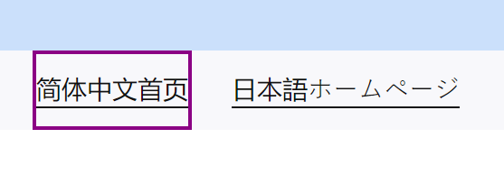

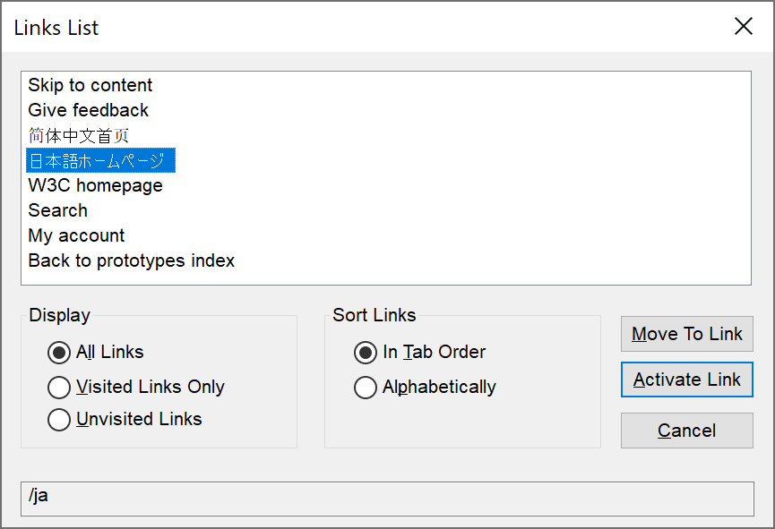

The language selector links are ambiguous for screen reader users browsing both in and out of context using JAWS and NVDA. While browsing in context both links are relayed as “Link”.

Users browsing out of context by isolating all of the links into a links list hear “3 of 7” and “4 of 7” – this is highly disorientating as the user is unable to ascertain the purpose of the links.

VoiceOver reads both links in Chinese and Japanese.

The ‘hreflang’ appears to be interfering with how screen reader software interprets the link in context.

**Current code ref(s)**:

<ul class="clean-list" role="list">

<li><a href="/zh" hreflang="zh-hans">简体中文首页</a></li>

<li><a href="/ja" hreflang="ja">日本語ホームページ</a></li>

</ul>

**Screen reader comments:**

“The language selector links were problematic for multiple types of screen reading software.

**JAWS:** I found that the links did not announce a link text either in or out of context. This was highly problematic as I would have been unable to understand what language was being selected. This would have prevented me from interacting with the links without sighted assistance to understand what link was being selected.

**NVDA:** The links announced the phrase ‘Chinese character’ on multiple occasions within the link text. It was not obvious what the links were indicating either in or out of context and would have prevented me from understanding the links without assistance.

**VoiceOver:** A series of characters announced to me. I was unable to understand the characters and would not have been aware in a non-testing environment what the characters were indicating. Please note that it was not possible to verify whether the characters were announcing correctly using this software”

**Issue consistent for the following pages:**

Global header signed in

[Global header - signed in | W3C Redesign Prototypes (studio24.dev)](https://w3c-dev.studio24.dev/header-signedin/index.html)

Default page

<https://w3c-dev.studio24.dev/default/index.html>

Landing page

<https://w3c-dev.studio24.dev/landing/index.html>

Business ecosystem

[Business ecosystem | W3C Redesign Prototypes (studio24.dev)](https://w3c-dev.studio24.dev/business/index.html)

**Tested in:** JAWS with Microsoft Edge Chromium and Google Chrome, NVDA with Firefox and VoiceOver for iPhone with Safari.

**Solution:**

Screen reader users do not know what the Chinese/Japanese characters are for as there is no context for the links. While they say, “Simplified Chinese Home” and “Japanese homepage” respectfully, this cannot be understood by users of other countries.

We recommend adding the lang attribute with the appropriate value so that the language is conveyed to the user as ‘Chinese’ and ‘Japanese’.

Ensure that the direction of the text is correct by using the dir attribute, as per:

[W3C’s Inline markup and bidirectional text in HTML](https://www.w3.org/International/articles/inline-bidi-markup/).

**Example:**

<ul class="clean-list" role="list">

<li><a href="/zh" hreflang="zh-hans" **lang="zh-hans" dir="ltr"**>简体中文首页</a></li>

<li><a href="/ja" hreflang="ja" **lang="ja" dir="ltr"**>日本語ホームページ</a></li>

</ul>

### Non-descriptive links 2

There were duplicated links that will take users to different destinations.

**WCAG Reference(s):**

2.4.4 Link Purpose – in context (Level A)

[Understanding Link Purpose (In Context)](https://www.w3.org/WAI/WCAG21/Understanding/link-purpose-in-context.html) | [How to Meet Link Purpose (In Context)](https://www.w3.org/WAI/WCAG21/quickref/#link-purpose-in-context)

2.4.9 Link Purpose - Link Only - (Level AAA)

[Understanding Link Purpose (Link Only)](https://www.w3.org/WAI/WCAG21/Understanding/link-purpose-link-only.html) | [How to Meet Link Purpose (Link Only)](https://www.w3.org/WAI/WCAG21/quickref/#link-purpose-link-only)

#### Issue ID: DAC-Non-descriptive-links-issue2

URL: <https://w3c-dev.studio24.dev/business/index.html>

Page title: Business ecosystem | W3C Redesign Prototypes

Journey: Business ecosystem page

Screenshot:

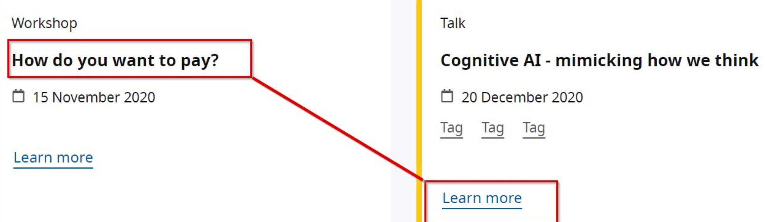

The link entitled ‘Learn more’ has been incorrectly associated with the ‘How do you want to pay?’ section of the page. This will be confusing for screen reader users at it has duplicated the previous link an screen reader users will be unable to differentiate between the two link.

**Current code ref(s)**:

<a href="../page.html">

<span class="visuallyhidden">**How do you want to pay?**</span> Learn more</a>

**Solution:**

Amend the link so that it is not duplicated and is descriptive of its purpose and/or destination.

**Example:**<a href="../page.html">

<span class="visuallyhidden">**Cognitive AI – mimicking how we think**</span> Learn more</a>

### Non-descriptive image

The wording of the SVG title may be confusing for some users.

**WCAG Reference:**

1.1.1 Non-text Content (Level A)

[Understanding Non-text Content](https://www.w3.org/WAI/WCAG21/Understanding/non-text-content.html) | [How to Meet Non-text Content](https://www.w3.org/WAI/WCAG21/quickref/#non-text-content)

#### Issue ID: DAC-Non-descriptive-image

URL: <https://w3c-dev.studio24.dev/header-signedin/index.html>

Page title: Global header - signed in | W3C Redesign Prototypes

Journey- Header – signed in

Screenshot:

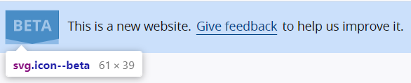

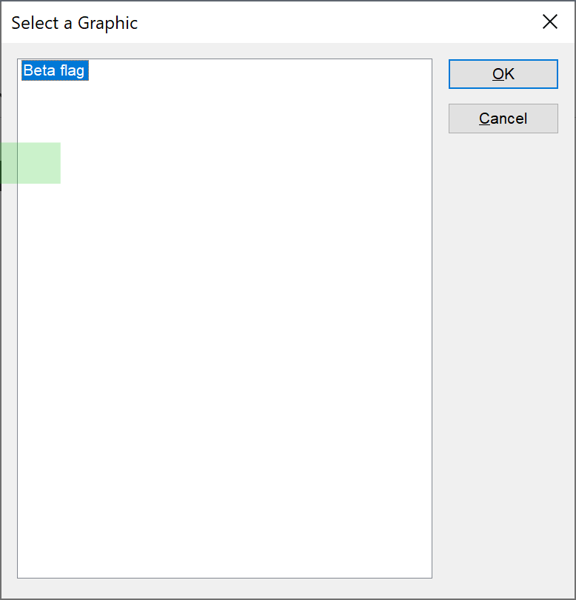

There is an image on the page entitled ‘Beta flag’ which may be ambiguous for some screen reader users when browsing both in and out of context. The word ‘flag’ may be confusing for some users as to what the flag represents, although there is no flag present on the page.

**Current code ref(s)**:

<svg role="img" class="icon--beta" xmlns="http://www.w3.org/2000/svg" viewBox="0 0 61 39" width="61px" height="39px">

<title>**Beta flag**</title>

**Screen reader comments:**

“I located an image on the page which announced to me as ‘Beta flag.’ It may not be clear to all users what is being indicated by the image description. It would assist users if the phrase ‘Flag’ could be removed, with the phrase ‘Logo’ added after ‘Beta’ to provide a clear indication of what the image is displaying. **The issue occurs with JAWS, NVDA and VoiceOver for iPhone.**”

**Issue consistent for the following pages:**

Global header signed in

[Global header - signed in | W3C Redesign Prototypes (studio24.dev)](https://w3c-dev.studio24.dev/header-signedin/index.html)

Default page

<https://w3c-dev.studio24.dev/default/index.html>

Landing page

<https://w3c-dev.studio24.dev/landing/index.html>

Business ecosystem

[Business ecosystem | W3C Redesign Prototypes (studio24.dev)](https://w3c-dev.studio24.dev/business/index.html)

**Tested in:** JAWS with Microsoft Edge Chromium and Google Chrome, NVDA with Firefox and VoiceOver for iPhone with Safari.

**Solution:**

You could either provide the BETA information via text (which is how most GOV.UK services implement their BETA banners) or you could change the title of the SVG so that the purpose of the image is clear.

### Decorative images

A decorative image was discoverable for screen reader users.

**WCAG Reference:**

1.1.1 Non-text Content (Level A)

[Understanding Non-text Content](https://www.w3.org/WAI/WCAG21/Understanding/non-text-content.html) | [How to Meet Non-text Content](https://www.w3.org/WAI/WCAG21/quickref/#non-text-content)

#### Issue ID: DAC-Decorative-images-Issue1

URL: <https://w3c-dev.studio24.dev/default/index.html>

Page title: W3C Mission (Default template) | W3C Redesign Prototypes

Journey: Default page

Screenshot:

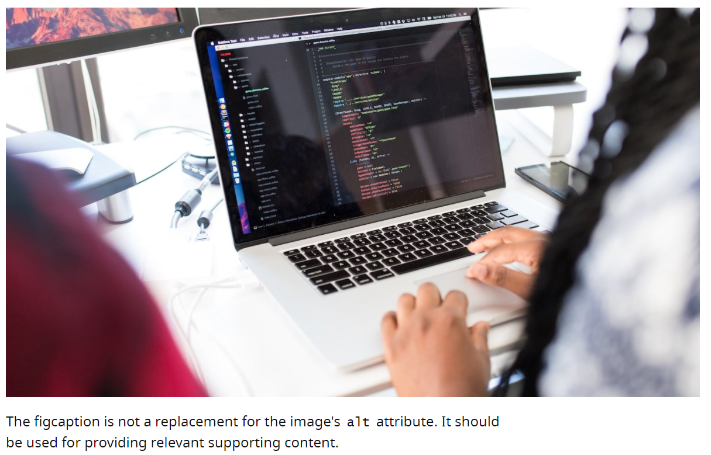

Decorative images can often be confusing or time-consuming for screen readers to navigate past especially if there are multiple images on the page. It is currently not clear whether this image is being used as example for the prototype, or if it is intended to convey information to blind users.

**Please note:** on the ‘Landing page prototype’ there are a high number of similar images that should also be ignored using the null alt text.

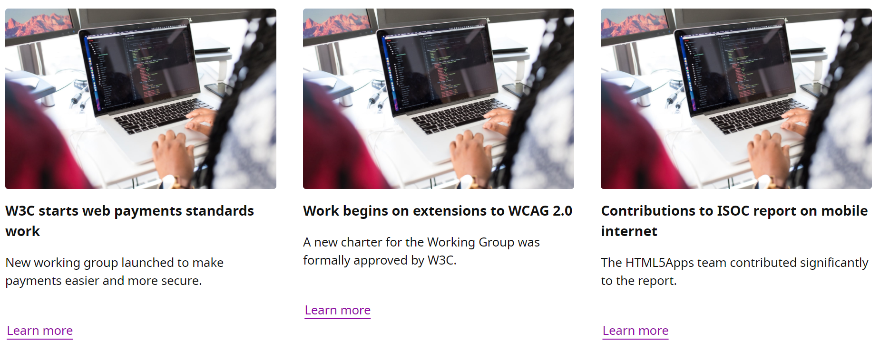

**Current code ref(s)**:

<img src="dist/assets/images/temp-developers-920.jpg" srcset="dist/assets/images/temp-developers-360.jpg 360w, dist/assets/images/temp-developers-580.jpg 580w, dist/assets/images/temp-developers-920.jpg 920w, dist/assets/images/temp-developers-1520.jpg 1520w" loading="lazy" **alt="A Macbook screen with code, as seen from over the developer's shoulder"**>

**Screen reader comments:**

“I located multiple images on the page which began with the phrase ‘A Macbook screen.’ These images may cause some disorientation to some screen reader users as the images are duplicated which may mean that users are not aware of where they are situated on the page. I further found that the images although descriptive did not add further useful information to the user journey and were time consuming to move past. It would assist screen reader users if all images could be hidden from screen reader users with the exception of images that either indicate a logo or are essential to the user journey. Alternatively all images should be given a unique description to avoid potential disorientation. **The issue is present with JAWS, NVDA and VoiceOver for iPhone.**”

**Issue consistent for the following pages:**

Landing page

<https://w3c-dev.studio24.dev/landing/index.html>

Business ecosystem

[Business ecosystem | W3C Redesign Prototypes (studio24.dev)](https://w3c-dev.studio24.dev/business/index.html)

**Tested in:** JAWS with Microsoft Edge Chromium and Google Chrome, NVDA with Firefox and VoiceOver for iPhone with Safari.

**Solution:**

The image does not appear to convey any meaningful information for blind users, so we recommend ensuring the image is ignored by screen reader users. This can be achieved by implementing null alt text.

**Example:**<img src="dist/assets/images/temp-developers-920.jpg" srcset="dist/assets/images/temp-developers-360.jpg 360w, dist/assets/images/temp-developers-580.jpg 580w, dist/assets/images/temp-developers-920.jpg 920w, dist/assets/images/temp-developers-1520.jpg 1520w" loading="lazy" **alt=""**>

### Carousel

The carousel feature was problematic for a screen reader user.

**WCAG Reference:**

2.4.3 Focus Order (Level A)

[Understanding Focus Order](https://www.w3.org/WAI/WCAG21/Understanding/focus-order.html) | [How to Meet Focus Order](https://www.w3.org/WAI/WCAG21/quickref/#focus-order)

4.1.2 Name, Role, Value (Level A)

[Understanding Name, Role, Value](https://www.w3.org/WAI/WCAG21/Understanding/name-role-value.html) | [How to Meet Name, Role, Value](https://www.w3.org/WAI/WCAG21/quickref/#name-role-value)

#### Issue ID: DAC-Carousel-Issue1

URL: <https://w3c-dev.studio24.dev/business/index.html>

Page title: Business ecosystem | W3C Redesign Prototypes

Journey: Business ecosystem page

Screenshot:

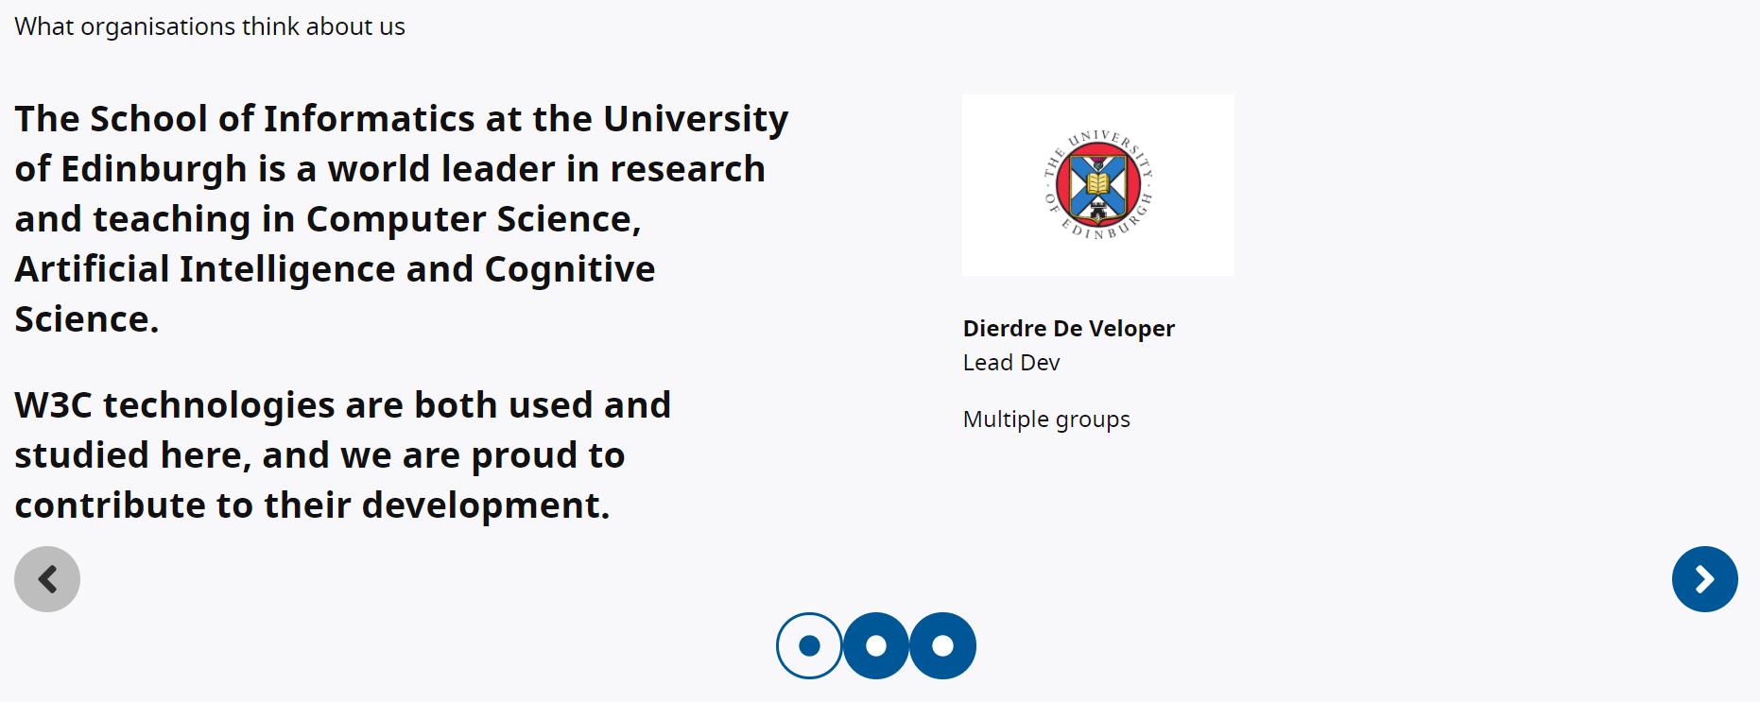

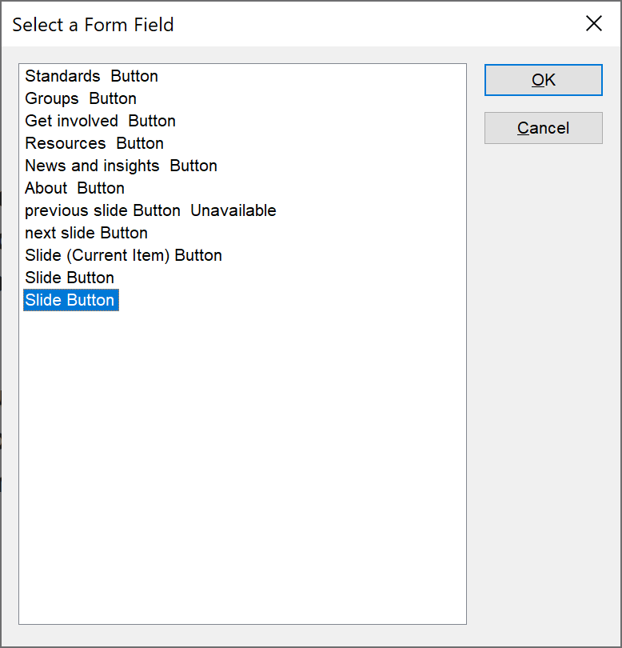

There are a number of issues with the carousel feature for screen reader users. When a screen reader interacts with the next/previous slide buttons focus shifts to the top of the page. This will be highly disorientating for a screen reader as this is unexpected.

Another issue identified was the duplicated ‘Slide buttons’ which open different slides, however, screen readers will not be able to make that connection with duplicated labelling.

The first slide button has additional hidden text to inform the user that they are on the current slide, however, this does not change when other slide buttons are selected. This is highly confusing and disorientating.

When all buttons relating to the carousel are selected there is no indication to the user that a new slide is present, and the user has to navigate backwards scanning through each slide in an illogical manner to read the slide.

**Current code ref(s)**:

<button class="button current" data-slide="0">

<span class="visuallyhidden">Slide</span>

<svg xmlns="http://www.w3.org/2000/svg" viewBox="0 0 512 512" class="icon"   
 focusable="false" aria-hidden="true" width="1em" height="1em"> … </svg>

**<span class="visuallyhidden">(Current Item)</span>**

</button>

<button class="button " data-slide="1">

**<span class="visuallyhidden">Slide</span>**

**Screen reader comments:**

“I found the carousel functionality highly challenging to both understand and use and would have been prevented from using the functionality without sighted assistance.

The buttons to select a carousel slide were duplicated announcing to me as ‘Slide.’ This made it highly challenging for me to identify which slide was being selected. Ensuring that specific information such as the number of the slide is included within the label of the button will avoid this confusion in relation to the label of each button. The issue occurred with JAWS, NVDA and VoiceOver for iPhone.

The first button announced as ‘Current’ even when the slide had updated. This was confusing for me as I was unable to determine whether the slide had changed or updated. A member of the support team confirmed that visually the current button had changed, but this was not conveyed by the screen reading software.

When I selected the ‘Next slide’ and ‘Previous slide’ buttons twice to cycle through the slides with JAWS my focus was taken to the top of the page. This could be disorientating for some screen reader users and made it highly time consuming to move back to the carousel feature. **The issue did not occur with NVDA or VoiceOver for iPhone**.

When I selected the slide buttons was advised by the support team that visually the slide updated. However I was not given an indication that the slide had updated. Furthermore the slide was situated above my present position which was confusing. Ensuring that an indication is given that the slide has updated with focus moving to the slide will avoid this difficulty. **The issue is consistent with JAWS, NVDA and VoiceOver for iPhone**.

Finally I found that when situated at the top of the first slide when moving in context I moved directly to the next slide. I was unable to determine whether the slides had changed or updated or when I had moved to the next slide. A member of the support team advised me that visually the slide did not update until I had scrolled to the next slide. This would have prevented me from understanding the content and caused me significant confusion. It would assist me if the slides did not scroll but instead remained static with one slide on the page which does not update until the next slide feature is selected. Alternatively, it may benefit users if the carousel functionality could be removed with all information available on the page as in its present format the carousel controls are obsolete for screen reader users and cause significant disorientation and confusion. **The issue occurs with JAWS, NVDA and VoiceOver for iPhone.**”

**Tested in:** JAWS with Microsoft Edge Chromium and Google Chrome, NVDA with Firefox and VoiceOver for iPhone with Safari.

**Solution:**

Provide descriptive labels for each individual button so that screen readers can determine their purpose.

**Example:**

<button class="button " data-slide="1">

<span class="visuallyhidden">**Slide 2**</span>

**OR**

<button class="button " data-slide="1">

<span class="visuallyhidden">**Slide 2 of 3**</span>

Ensure the <span> used to inform screen readers that they are on the current item changes to reflect whichever slide they have selected.

Inform the user of the changes in the carousel by implementing an aria-live region when the ‘next/previous’ buttons are initiated.

### Incorrect use of ARIA

The table caption is repeated to screen reader users and the grouping method is announced to screen reader users.

**WCAG Reference:**

4.1.2 Name, Role, Value (Level A)

[Understanding Name, Role, Value](https://www.w3.org/WAI/WCAG21/Understanding/name-role-value.html) | [How to Meet Name, Role, Value](https://www.w3.org/WAI/WCAG21/quickref/#name-role-value)

#### Issue ID: DAC-Incorrect-use-of-ARIA

URL: <https://w3c-dev.studio24.dev/default/index.html#main>

Page title: W3C Mission (Default template) | W3C Redesign Prototypes

Journey: Default page

Screenshot:

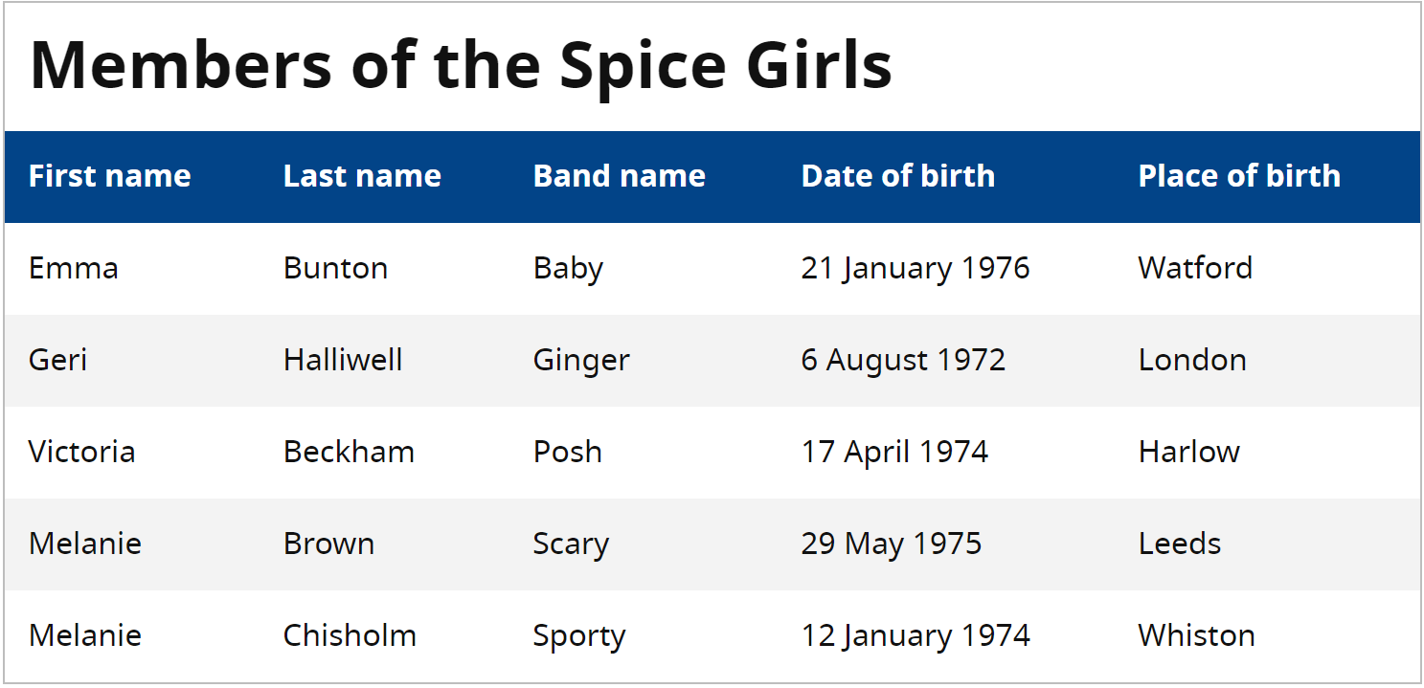

The table caption is repeated twice to screen reader users due the use of aria-labelledby and the actual caption. This is not required as it causes extra navigational steps. The aria role of ‘group’ is also not required in this instance.

**Current code ref(s)**:

<div class="table-wrap" **role="group"** **aria-labelledby="unique-caption-id"** tabindex="-1">

<caption id="unique-caption-id" class="txt-earth bold">Members of the Spice Girls</caption>

**Screen reader comments:**

“I found that the table containing information relating to the Spice Girls was situated within a role of group when using JAWS and NVDA. This was confusing as the table mark-up itself was clear meaning that no group was required as there was no content to be grouped.

**VoiceOver:** The group was not located, however a series of non-descriptive content announced after the table caption which was confusing.

The technical auditor advised me that the group related to the table caption, however this was not obvious and was not expected behaviour. It would benefit screen reader users if the table caption could either be presented as text directly before the table, as a heading directly before the table or as a caption inside of the table with the role of group removed.”

**Tested in:** JAWS with Microsoft Edge Chromium and Google Chrome, NVDA with Firefox and VoiceOver for iPhone with Safari.

**Solution:**

Remove aria-labelledby attribute so that users relying on audio feedback only hear the table caption once. The **role="group"** and the **aria-labelledby** attribute is superfluous and must be removed.

## Medium priority

### Non-descriptive heading

There is a heading on the page that is not descriptive.

**WCAG Reference:**

2.4.6 Headings and Labels (Level AA)

[Understanding Headings and Labels](https://www.w3.org/WAI/WCAG21/Understanding/headings-and-labels.html) | [How to Meet Headings and Labels](https://www.w3.org/WAI/WCAG21/quickref/#headings-and-labels)

#### Issue ID: DAC-Non-descriptive-heading-Issue1

URL: <https://w3c-dev.studio24.dev/default/index.html#main>

Page title: W3C Mission (Default template) | W3C Redesign Prototypes

Journey: Default page

Screenshot:

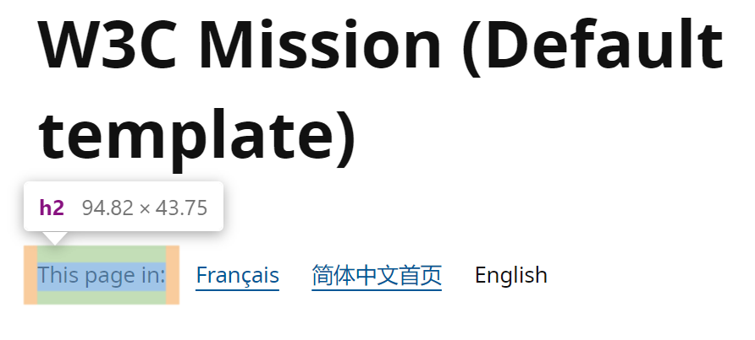

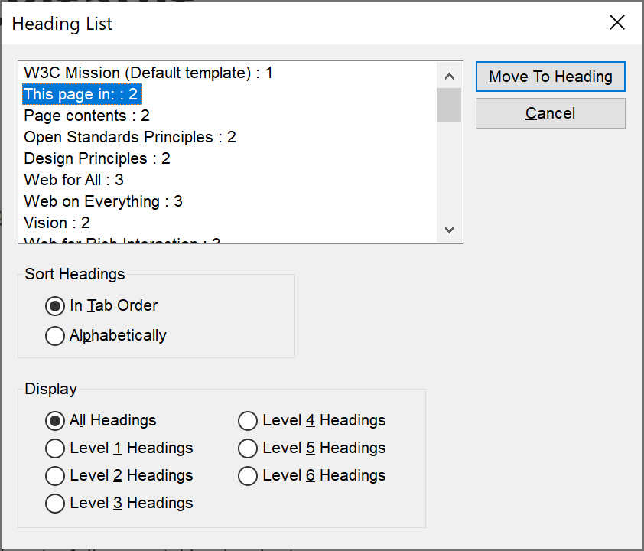

The heading entitled ‘This page in:’ is not descriptive of what it is introducing. It is introducing a number of links used to change the language of the page.

This may be an issue for some screen reader users using the heading structure as a way of navigating as the purpose of this section is not clear.

**Current code ref(s)**:

<h2>This page in:</h2>

**Screen reader comments:**

“I located a heading which announced to me as This page in.’ It was not immediately clear to me when browsing out of context what the heading was indicating. After investigation in context, I discovered that the heading was introducing a second language selector, but this was not clear from the text of the heading. I further found that the heading and language selector appeared directly after the h1. This may initially be confusing for some screen reader users as many may expect the h1 to introduce the main content of the page. I would expect the language selector to be placed within the header of the page and not directly after the h1. It would benefit screen reader users if the language selector on the page could be presented as a single item within the header of the page, with the first h2 on the page introducing the contents section directly after the h1. **The issue occurs with JAWS, NVDA and VoiceOver for iPhone.**”

**Tested in:** JAWS with Microsoft Edge Chromium and Google Chrome, NVDA with Firefox and VoiceOver for iPhone with Safari.

**Solution:**

We recommend amending the heading, so it is descriptive of the section of the page it is introducing.

**Examples:**<h2>View this page in:</h2>

**OR**

<h2>Language selector<h2>

### Non-descriptive labelling

The labelling of the ‘back to menu’ button is not descriptive.

**WCAG Reference:**

2.4.6 Headings and Labels (Level AA)

[Understanding Headings and Labels](https://www.w3.org/WAI/WCAG21/Understanding/headings-and-labels.html) | [How to Meet Headings and Labels](https://www.w3.org/WAI/WCAG21/quickref/#headings-and-labels)

#### Issue ID: DAC-Non-descriptive-labelling-Issue1

Journey: All pages

Screenshot:

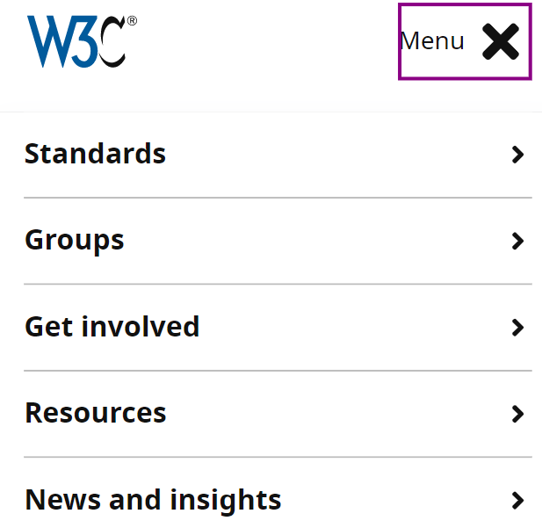

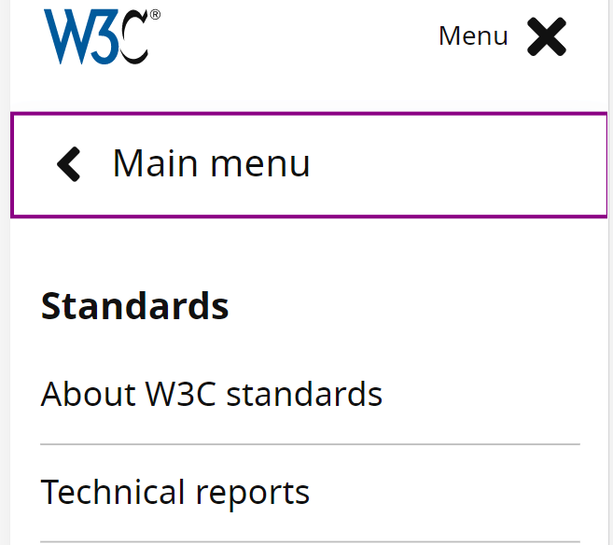

When the mobile navigation menu is initiated and the ‘Standard’ link is selected, users would expect to interact with the links within this section first. This is not the case as a ‘back to menu’ style button is present taking focus first. Visually the buttons purpose is clear, however, the purpose of the button will be unclear for blind users. There are now two buttons entitled ‘Menu’ and ‘Main menu’ which may be confusing.

**Current code ref(s)**:

<button type="button" class="button button--ghost u-full-width with-icon--before with-icon--larger" data-trigger="mobile-back">

<svg class="icon icon--larger" xmlns="http://www.w3.org/2000/svg" focusable="false" aria-hidden="true" viewBox="0 0 256 512" width="1em" height="1em"> … </svg>**Main menu**</button>

**Screen reader comments:**

“With VoiceOver for iPhone when I expanded one of the buttons within the hamburger menu and swiped once I located another button which announced to me as ‘Main menu.’ When the button was selected this performed the same function as the button I had previously selected by collapsing the content. This could be confusing for some VoiceOver users and made it more time consuming to identify the links within the menu. It would benefit screen reader users if the ‘Main menu’ buttons could be removed as they are not necessary functionality. **The issue does not occur with other screen reading software tested.”**

**Issue consistent for the following pages:**

Landing page

<https://w3c-dev.studio24.dev/landing/index.html>

Business ecosystem

[Business ecosystem | W3C Redesign Prototypes (studio24.dev)](https://w3c-dev.studio24.dev/business/index.html)

**Tested in:** JAWS with Microsoft Edge Chromium and Google Chrome, NVDA with Firefox and VoiceOver for iPhone with Safari.

**Solution:**Amend the label so that it is descriptive of its purpose.

**Example:**

<button type="button" class="button button--ghost u-full-width with-icon--before with-icon--larger" data-trigger="mobile-back">

<svg class="icon icon--larger" xmlns="http://www.w3.org/2000/svg" focusable="false" aria-hidden="true" viewBox="0 0 256 512" width="1em" height="1em"> … </svg>**Back to main menu**</button>

Alternatively, you could provide an aria-label to convey this information if you feel the button text is too long and may interfere with the UI.

**Example:**  
<button **aria=label="Back to main menu"** type="button" class="button button--ghost u-full-width with-icon--before with-icon--larger" data-trigger="mobile-back">

## A picture containing clipart Description automatically generatedLow priority

### Video content

The video did not provide sign language interpretation.

**WCAG Reference:**

1.2.6 Sign Language - Prerecorded (Level AAA)

[Understanding Sign Language (Prerecorded)](https://www.w3.org/WAI/WCAG21/Understanding/sign-language-prerecorded.html) | [How to Meet Sign Language (Prerecorded)](https://www.w3.org/WAI/WCAG21/quickref/#sign-language-prerecorded)

#### Issue ID: DAC-Video-Content-Issue1

URL: <https://w3c-dev.studio24.dev/landing/index.html>

Page title: Landing page | W3C Redesign Prototypes

Journey: landing page

Screenshot:

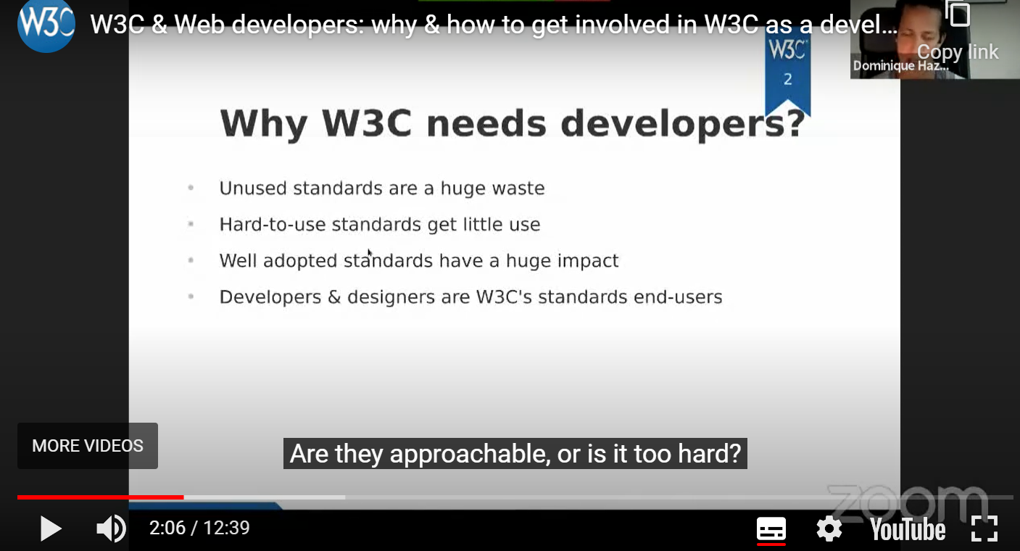

Written text for some deaf users may be their second language so it is beneficial for this user group to provide sign language. Sign language provides secondary information such as emotions and other audio information that is not reflected in captions.

**Current code ref(s)**: **N/A**

**Solution:**Sufficient Techniques to pass this guideline:

1. [G54: Including a sign language interpreter in the video stream](https://www.w3.org/WAI/WCAG21/Techniques/general/G54)
2. [G81: Providing a synchronized video of the sign language interpreter that can be displayed in a different viewport or overlaid on the image by the player](https://www.w3.org/WAI/WCAG21/Techniques/general/G81) **using one of the following techniques:**
   * [SM13: Providing sign language interpretation through synchronized video streams in SMIL 1.0](https://www.w3.org/WAI/WCAG21/Techniques/smil/SM13)
   * [SM14: Providing sign language interpretation through synchronized video streams in SMIL 2.0](https://www.w3.org/WAI/WCAG21/Techniques/smil/SM14)

## Usability

### Nested landmarks

The aside landmark has been nested within the main landmark.

**WCAG Reference:**

Usability

#### Issue ID: DAC-Nested-landmarks

URL: <https://w3c-dev.studio24.dev/default/index.html>

Page title: W3C Mission (Default template) | W3C Redesign Prototypes

Journey: Default page

Screenshot:

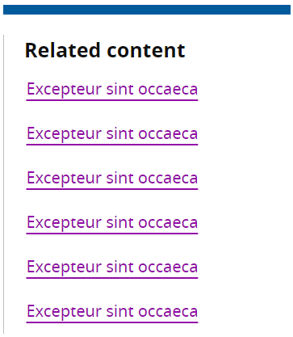

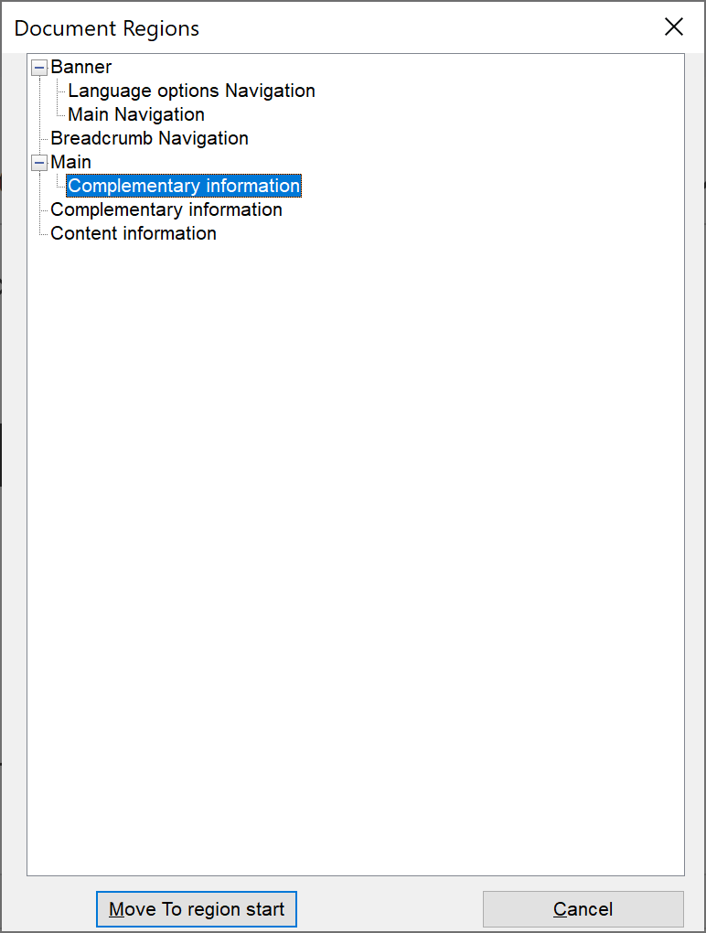

Nested landmarks can be confusing for screen readers especially for users navigating via the landmark shortcut. Screen reader users can skip to certain landmarks via the ‘R’ shortcut key, but the aside landmark may be missed by some software if it is not top-level. The aside landmark should be a top-level landmark.

**Current code ref(s)**:

<main id="main">

<div class="content">

<article> … </article>

<aside class="related">

<div class="related\_\_inner">

<h2 class="txt-jupiter">Related content</h2>

**Screen reader comments:**

“I discovered that the ‘Complimentary’ landmark was situated inside of the main content landmark. This could be confusing for some screen reader users attempting to understand the structure of the page by viewing the landmarks. Placing the complimentary landmark after the main content section will avoid any potential difficulty. **The issue is consistent with JAWS, NVDA and VoiceOver for iPhone.**”

**Tested in:** JAWS with Microsoft Edge Chromium and Google Chrome, NVDA with Firefox and VoiceOver for iPhone with Safari.

**Solution:**

After looking at the layout, it can be determined that this “Related content” section is not part of the main content. Place the aside landmark outside of the main landmark ensuring it is a top-level landmark.

### Same page skip links

In-page skip links are not announced to NVDA users.

**WCAG Reference:**

Usability

#### Issue ID: DAC-Same-page-skip-links

URL: <https://w3c-dev.studio24.dev/default/index.html#main>

Page title: W3C Mission (Default template) | W3C Redesign Prototypes

Journey: Default page

Screenshot:

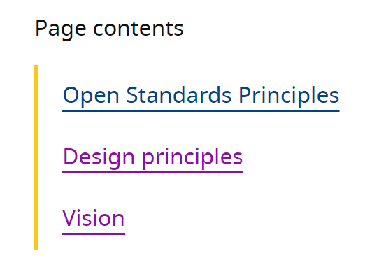

Screen reader software such as NVDA for example does not convey the functionality of same page skip links to users. Although a minor issue, this may be problematic for some NVDA users. Extra information may make the overall user experience a better one for this user group.

**Current code ref(s)**:

<ul class="clean-list" role="list">

<li><a href="#open-standards-principles">Open Standards Principles</a></li>

<li><a href="#design-principles">Design principles</a></li>

<li><a href="#vision">Vision</a></li>

</ul>

**Screen reader comments:**

“I located a series of in page links situated within the ‘Page contents section.’ Although these were marked-up correctly and performed as expected NVDA does not presently support the announcing of in page links, presenting them as standard links. This may mean that NVDA users are not aware that focus will move which could be disorientating. Adding a small phrase to the beginning of each in page link text for example ‘Move to’ or ‘Jump to’ would ensure that all screen reader users with all software are aware that focus will move.”

**Solution:**

Consider either introducing the links via a descriptive heading describing their purpose or add some additional hidden text to convey the functionality of the link.

**Examples:**

**Using a heading**<h2>**Page contents skip to links**</h2> **Using hidden text:**

**HTML**

<a href="#open-standards-principles">Open Standards Principles<span class="**visuallyhidden**">in-page skip link</span></a>

**CSS**

.**visuallyhidden**

{

position: absolute; width: 1px; height: 1px; margin: -1px; padding: 0; overflow: hidden;

clip: rect(0,0,0,0); border: 0;

}

**Alternatively, an aria-label can be used instead.**

**aria-label**<a **aria-label="Open Standards Principles (in-page skip link**)" href="#open-standards-principles">Open Standards Principles</a

**Please note:** if you implement this then JAWS users will hear two instructions of “Same page link” and “In-page skip link” however, we feel this is not too confusing and would provide NVDA users with a better overall user experience.

### Reflow

The table is problematic to interact with for users using the reflow method.

**WCAG Reference:**

1.4.10 Reflow

[Understanding Reflow](https://www.w3.org/WAI/WCAG21/Understanding/reflow.html) | [How to Meet Reflow](https://www.w3.org/WAI/WCAG21/quickref/#reflow)

#### Issue ID: DAC-Reflow

URL: <https://w3c-dev.studio24.dev/default/index.html#main>

Page title: W3C Mission (Default template) | W3C Redesign Prototypes

Journey: Default page

Screenshot:

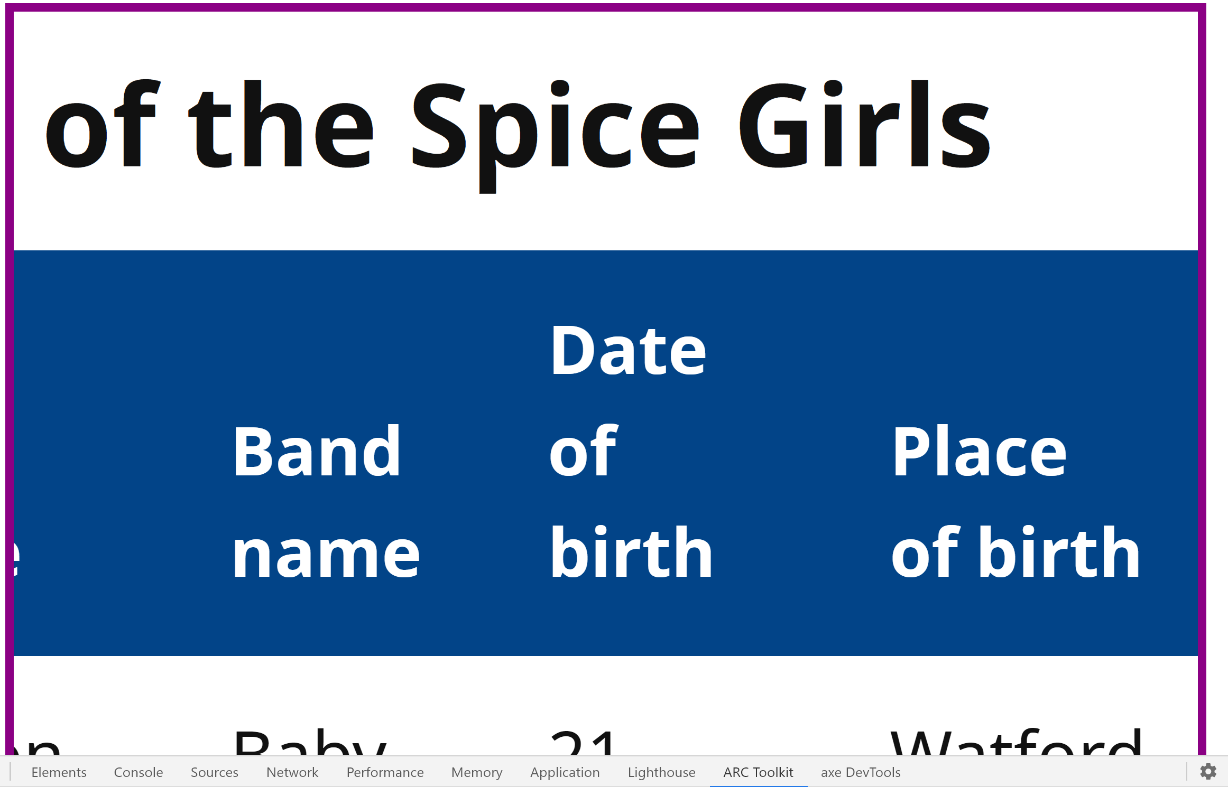

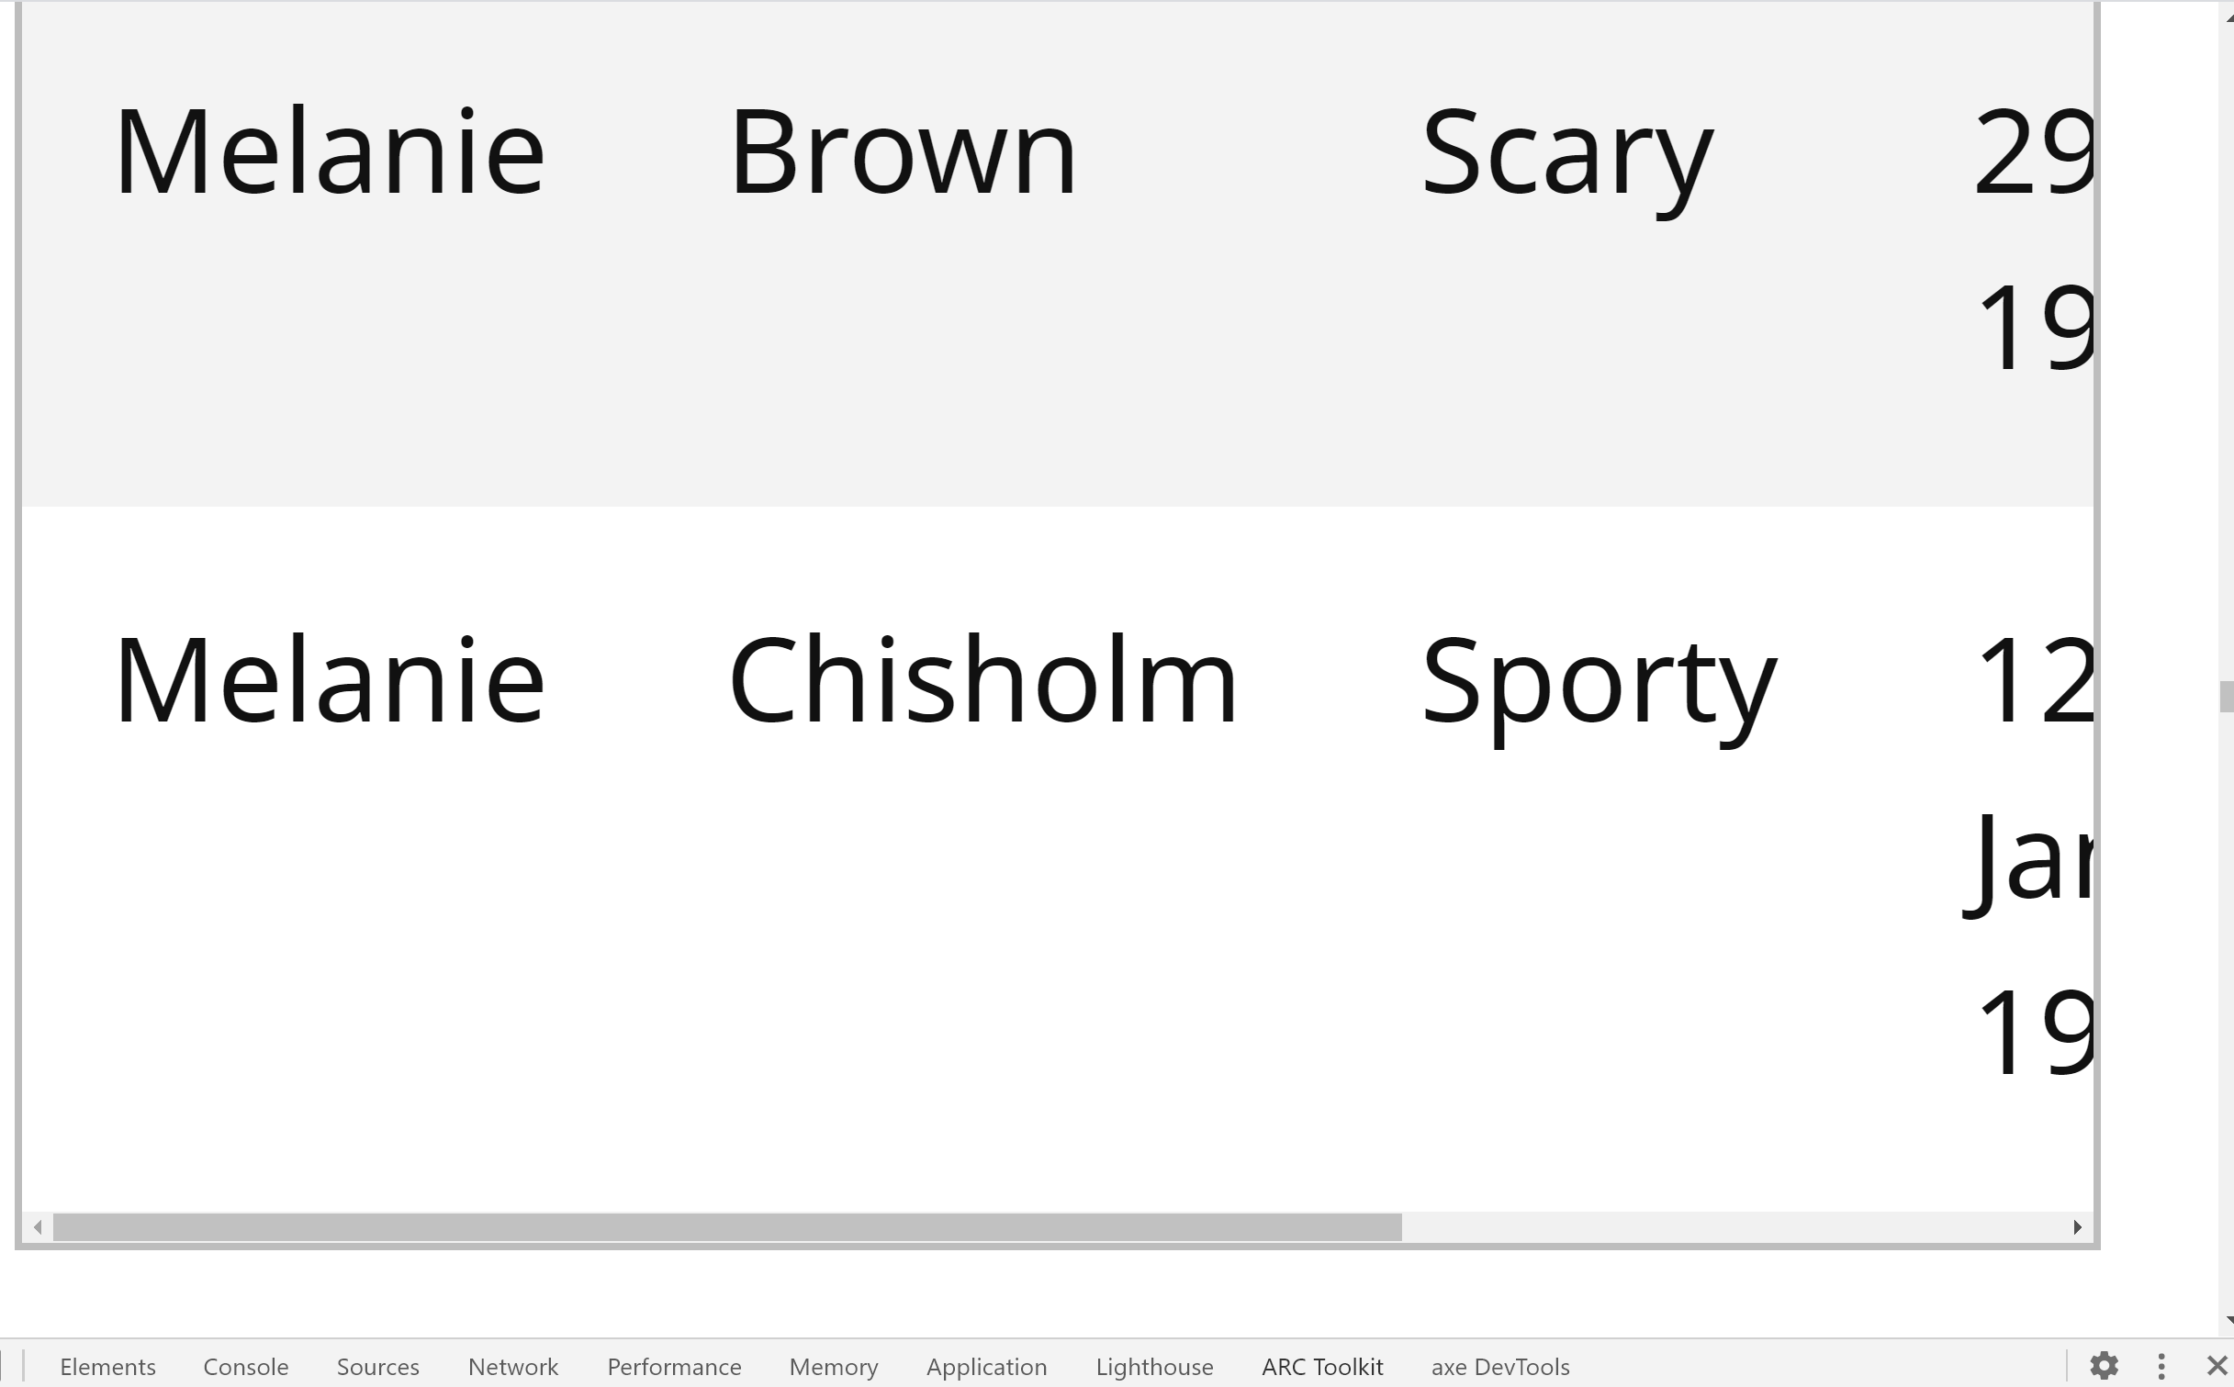

Although tables are included as content that allows and requires two-dimensional layouts, the way in which the table is presented to users using the Reflow technique is highly problematic and time-consuming.

To view the content within the table, users must use an internal horizontal scrolling mechanism moving left or right, then then the page up/down scrolling mechanism from the browser. Users must switch between the two a number of times if they want to view the tables contents.

The user can also highlight text using the mouse and scroll to left/right with the mouse to view the content, but this is not the expected way to interact with content.

This will affect low vision users or any users that prefer to read the page in a single column to improve their reading experience.

**Please note**: The reflow technique is when the browser is magnified to 400% and the browser width is set to 1280px.

**Current code ref(s):**

.pcf-header .pcf-cookie-message {

-webkit-animation-name: slideInDown;

animation-name: slideInDown;

-webkit-animation-iteration-count: 1;

animation-iteration-count: 1;

-webkit-animation-duration: .5s;

animation-duration: .5s;

-webkit-animation-delay: 0s;

animation-delay: 0s;

-webkit-animation-timing-function: ease;

animation-timing-function: ease;

-webkit-animation-fill-mode: both;

animation-fill-mode: both;

-webkit-backface-visibility: hidden;

backface-visibility: hidden;

**position: fixed;**

**Solution:**

Ensure content can be presented to users without **loss of information** or functionality.

### Changes in text presentation

The changes in text presentation are not conveyed to screen reader users.

**WCAG Reference:**

Usability

#### Issue ID: DAC-Changes-in-text-presentation

URL: <https://w3c-dev.studio24.dev/default/index.html#main>

Page title: W3C Mission (Default template) | W3C Redesign Prototypes

Journey: Default page

Screenshot:

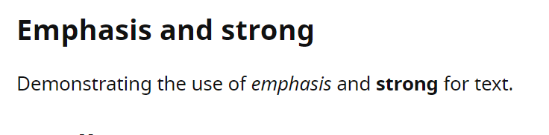

Screen reader users or users that rely on audio feedback will be unable to determine that the text is bold or emphasised. This is because there is no appropriate markup to convey the difference in text.

**Current code ref(s)**:

<p>Demonstrating the use of <em>emphasis</em> and <strong>strong</strong> for text.</p>

**Screen reader comments:**

“I found that examples of ‘Strong’ ‘Small’ and ‘enthesis’ text were provided.

**JAWS and NVDA:** I was not provided with an indication from the software that any difference had occurred. I would not have been made aware that there was any visual change to the text.

**VoiceOver:** The visual text appeared on its own separate line, however I would not have been aware that there was any special significance to this text as the software did not announce any further prompt.

It would benefit screen reader users if the examples provided are not used, with other methods for example a warning, or a heading used instead to indicate text of special significance.”

**Tested in:** JAWS with Microsoft Edge Chromium and Google Chrome, NVDA with Firefox and VoiceOver for iPhone with Safari.

**Solution:**

You could provide some hidden text informing the user that the text is bold or emphasised. The use of <strong> and <em> does not appear to work as standard for some browsers assistive technology.

### Potential JAWS version bug

The status message does not announce for JAWS 2018 users.

**WCAG Reference:**

Usability

#### Issue ID: DAC-Potential-JAWS-version-bug

URL: <https://w3c-dev.studio24.dev/header-signedin/index.html>

Page title: Global header - signed in | W3C Redesign Prototypes

Journey- Header – signed in

Screenshot:

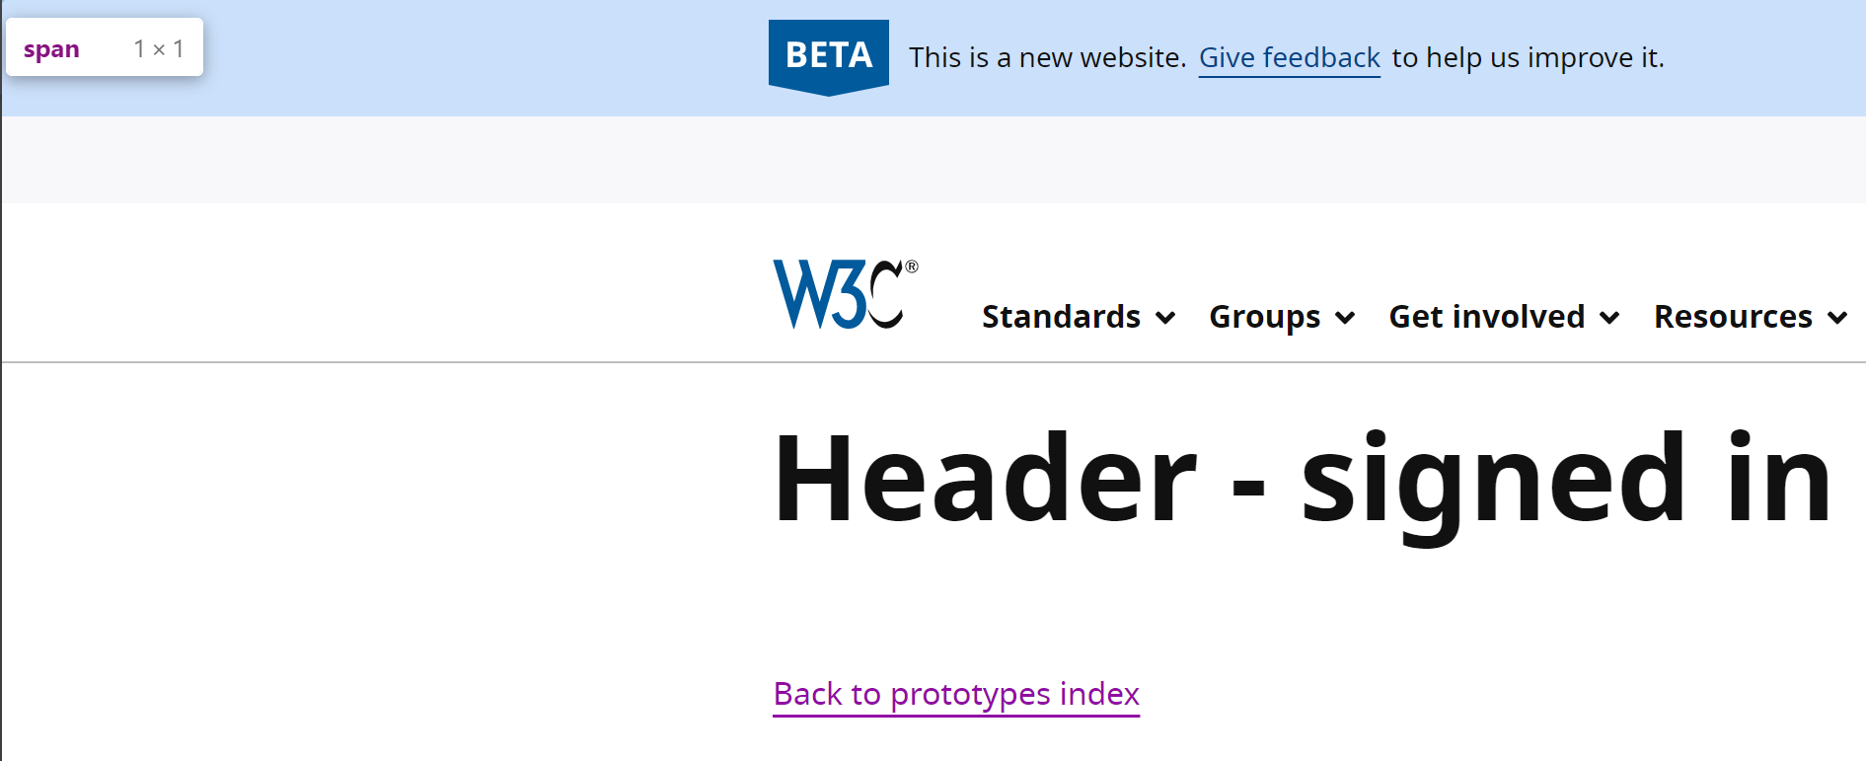

The status message to inform users that rely on audio feedback that they have unread messages is not conveyed to users using an older version of JAWS.

**Current code ref(s)**:

<span role="status" aria-live="polite">**You have unread messages**</span>

**Screen reader comments:**

“A message is present near to the top of the page when I entered the page.

**NVDA and VoiceOver:** A clear status message announced to advise me that the message was present.

**JAWS:** Using JAWS 2018 for both browsers tested the message did not announce, with the content of the page announcing instead. This was problematic for me as it was not immediately clear that the message was present on the page, with some screen reader users potentially by-passing the message with some methods of navigation such as the ‘Tab’ key.

The technical auditor confirmed that with JAWS 2019 the status message does clearly announce to screen reader users. This may mean that some screen reader uses may not locate the message depending on the combination of screen reader version and browser.”

**Tested in:** JAWS with Microsoft Edge Chromium and Google Chrome, NVDA with Firefox and VoiceOver for iPhone with Safari.

**Solution:**

No solution required, although you could inform users in your accessibility statement that up-to-date screen reader software is advisable as some accessibility issues may occur on older versions.

### Lists

The high number of lists used may be confusing for some screen reader users.

**WCAG Reference:**

Usability

#### Issue ID: DAC-Lists

URL: <https://w3c-dev.studio24.dev/landing/index.html>

Page title: Landing page | W3C Redesign Prototypes

Journey: Landing page

Screenshot:

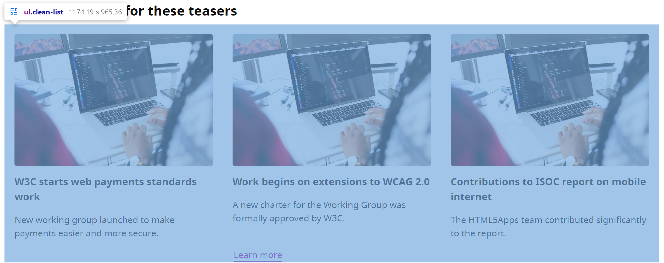

There are a large amount of list items used throughout the page that may be used for visual layout purposes. If this is the case, it may be beneficial if the markup could be ignored by screen reader users.

**Please note:** this markup was consistent on the ‘Business ecosystem’ page.

**Current code ref(s)**:

<div class="component component--columns component--columns--images">

<h2>Section heading for these teasers</h2>

<ul class="clean-list" role="list">

<li>

**Screen reader comments:**

“I found that many headings, links and images were situated within a list. This made it highly challenging to understand where one list item began and ended. As the headings introduce each new section it would assist screen reader users if the list could be removed as it is not necessary for this content to use a list. **The issue is present with JAWS, NVDA and VoiceOver for iPhone.**”

**Issue consistent for the following pages:**

Business ecosystem

[Business ecosystem | W3C Redesign Prototypes (studio24.dev)](https://w3c-dev.studio24.dev/business/index.html)

**Tested in: JAWS with Microsoft Edge Chromium and Google Chrome, NVDA with Firefox and VoiceOver for iPhone with Safari**

**Solution:**

Consider implementing **role="presentation"** so that the lists are ignored by screen reader users.

### Images

The decorative image was discoverable and time-consuming to swipe past.

**WCAG Reference:**

Usability

#### Issue ID: DAC-Images

URL: <https://w3c-dev.studio24.dev/landing/index.html>

Page title: Landing page | W3C Redesign Prototypes

Journey: landing page

Screenshot:



Although the image has been hidden from screen reader users using the null alt, it is still discoverable for VoiceOver users. Not only is the decorative image discoverable, but the user must also swipe fifteen times before being able to move past the image to gain focus on the heading entitled ‘Section heading for these teasers’.

**This is an iOS bug.** If the image source is an SVG, VoiceOver ignores the null alt.

**Current code ref(s)**:

<img src="dist/assets/svg/illustration-2.svg" alt="">

**Screen reader comments:**

“While swiping through the h1 section of the page in context with VoiceOver for iPhone I located a series of images for multiple swipes of the page which were time consuming to move past and were not descriptive. I was not aware of what the content related to and would have become confused in a non-testing environment as I would have believed that I was trapped on the image. **The issue does not occur with JAWS or NVDA.**”

**Issue consistent for the following pages:**

Business ecosystem

[Business ecosystem | W3C Redesign Prototypes (studio24.dev)](https://w3c-dev.studio24.dev/business/index.html)

**Solution:**

Ensure the image is hidden correctly and ignored by VoiceOver users. You can either implement **role="image"** or hide the image using **aria-hidden="true"**

### Third party issue

The element tags will be difficult for some users to decipher for some voice activation users.

**WCAG Reference:**

Usability **(high)**

#### Issue ID: DAC-Third-party-issue

URL: <https://w3c-dev.studio24.dev/header-signedin/index.html>

Page title: Global header - signed in | W3C Redesign Prototypes

Journey: All pages

Screenshot:

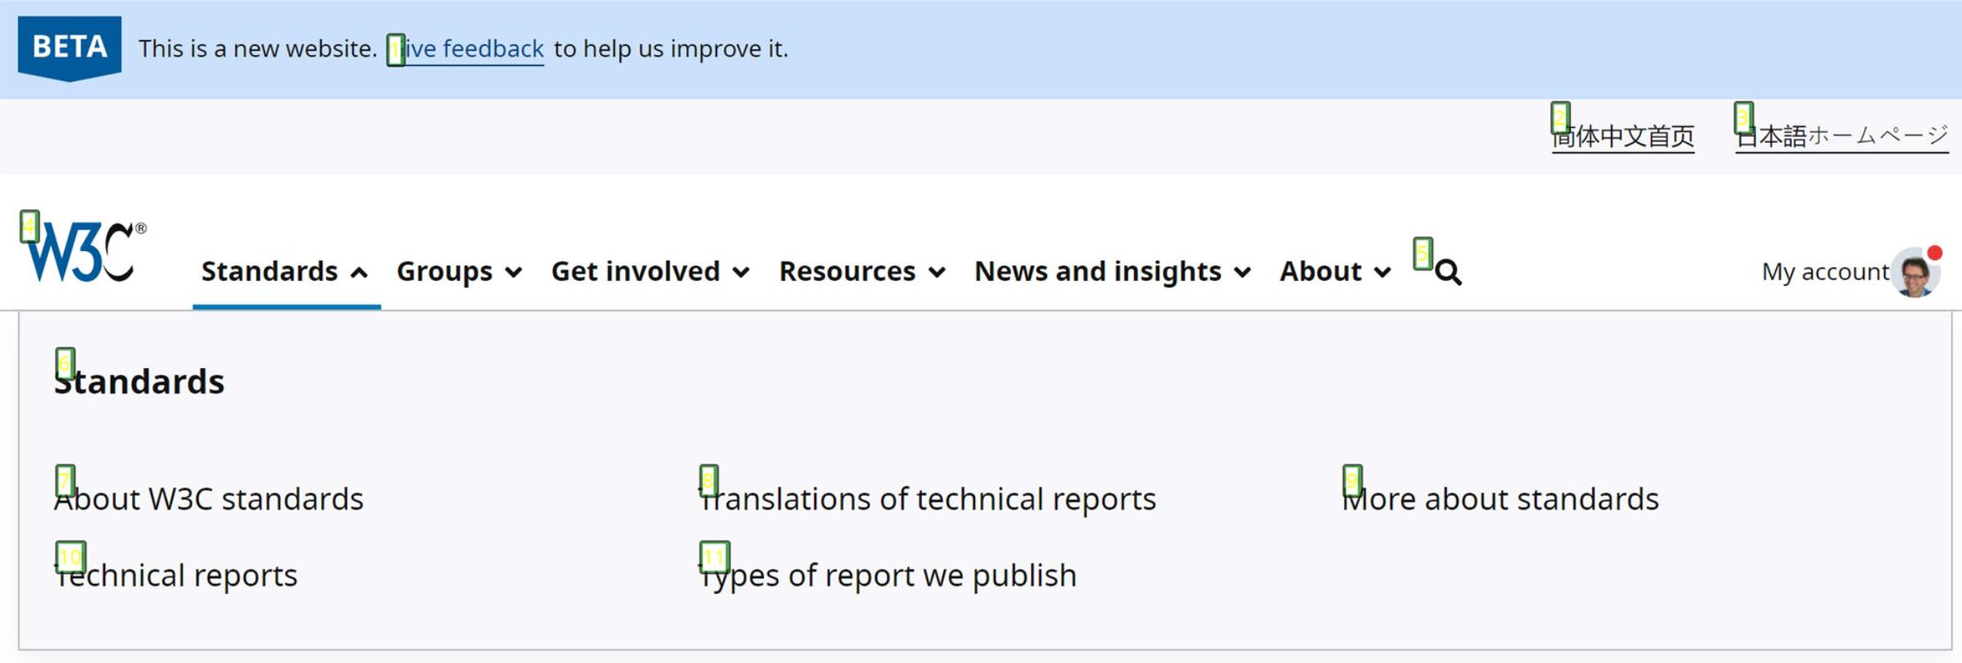



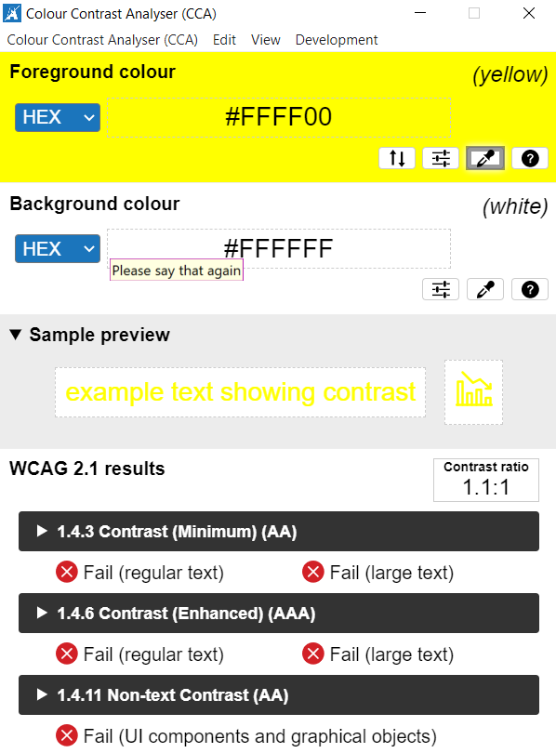

The element tags used to number elements on the page for Dragon users were extremely difficult to see. Interestingly, our voice activation analyst testing the pages did not see the yellow numbering and assumed the tags were empty. This will be highly problematic in a non-testing environment.

From a technical perspective, I could see the feint yellow, however, I was viewing the page on a large widescreen display monitor. I had to use scree magnification to decipher the numbers.

The **background-color: inherit;** in the CSS has changed the colour causing an extremely low colour contrast ratio of 1.1:1 with a bright yellow on the white background. This will also be highly problematic for Dragon users with a visual impairment.

**Please note:** this is consistent on all pages tested. Please also note, this did not come under any WCAG2.1 failures, however, it is a high usability issue and will affect all users unless the issue is fixed.

**Current code ref(s)**:

**HTML**

<a href="https://lists.w3.org/Archives/Public/public-website-redesign/">Give feedback</a>

**CSS**

\*, \*::before, \*::after {

**background-color: inherit;**

**Voce activation comments:**

“I was unable to interact with any elements on the page using standard voice commands such as ‘Click link’ or ‘Click button’ because the element tags were empty. This is not something I have experienced before while using Dragon NaturallySpeaking. I could, however, use the command ‘Click Standards’ which worked okay.”

**Solution:**

Remove the **background-color: inherit;** from the CSS to expose the default tags.

**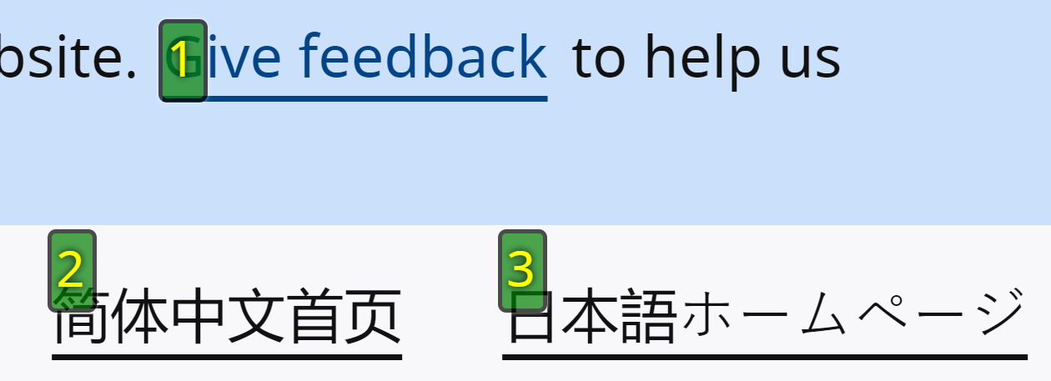**

# End of Report

## Appendix I

“From our prototype index at [https://w3c-dev.studio24.dev/](https://w3c-dev.studio24.dev/" \o "https://w3c-dev.studio24.dev/" \t "_blank) the items that can be tested now are:”

* Header – not signed in
* Header – signed in  
  (note header includes beta banner, language switcher top right, my account link. On the ‘my account link – signed in’ there is a notification button to indicate to a user there is some new activity for them to review. Nicki asked for this to be checked in particular)
* Default page – (everything but the section at the bottom with the blue background, titled ‘Section heading for these teasers’)
* Landing page – (everything but the section at the bottom with the blue background, titled ‘Section heading for these teasers’)
* Business ecosystem page – especially the carousel on this page (note some styling updates still need to be made for the carousel, but it shouldn’t affect the functionality of it)

## Appendix II

### Classification of Accessibility Issues

The following scoring system was used to indicate the status of the sites with regards to each W3C WAI checkpoint up to and including Level AAA:

|  |  |
| --- | --- |
| **Status** | **Description** |
| **Pass (P)** | The site meets the requirements of the checkpoint. |
| **Fail (L) Low Priority** | The site almost meets the requirements of the checkpoint. Only a small number of minor problems were identified. The site fails to meet the requirements against AAA criteria measured against WCAG 2.1 |
| **Fail (M) Medium Priority** | The site fails to meet the requirements against AA criteria measured against WCAG 2.1 |
| **Fail (H) High Priority** | The site fails to meet the requirements against A criteria measured against WCAG 2.1 and more severe accessibility issues were identified. |
| **Not Applicable (N/A))** | No content was found on the site to which the checkpoint would relate. |

|  |
| --- |
| **Principle 1: Perceivable – Information and users interface components must be presentable to users in ways they can perceive.** |
| **Non-text Content:**  [1.1.1](http://www.w3.org/TR/WCAG20/#text-equiv-all) All [non-text content](http://www.w3.org/TR/2008/REC-WCAG20-20081211/#non-text-contentdef) that is presented to the user has a [text alternative](http://www.w3.org/TR/2008/REC-WCAG20-20081211/#text-altdef) that serves the equivalent purpose.  (Level A) | **Fail (H)** |
| **Audio-only and Video-only (Pre-recorded):**  [1.2.1](http://www.w3.org/TR/WCAG20/#media-equiv-av-only-alt) For [pre-recorded](http://www.w3.org/TR/2008/REC-WCAG20-20081211/#prerecordeddef)  [audio-only](http://www.w3.org/TR/2008/REC-WCAG20-20081211/#audio-onlydef) and pre-recorded [video-only](http://www.w3.org/TR/2008/REC-WCAG20-20081211/#video-onlydef) media, the following are true, except when the audio or video is a [media alternative for text](http://www.w3.org/TR/2008/REC-WCAG20-20081211/#multimedia-alt-textdef) and is clearly labelled as such:  [Understanding Success Criterion 1.2.1](http://www.w3.org/TR/UNDERSTANDING-WCAG20/media-equiv-av-only-alt.html)   * **Pre-recorded Audio-only:** An [alternative for time-based media](http://www.w3.org/TR/2008/REC-WCAG20-20081211/#alt-time-based-mediadef) is provided that presents equivalent information for pre-recorded audio-only content. * **Pre-recorded Video-only:** Either an alternative for time-based media or an audio track is provided that presents equivalent information for pre-recorded video-only content.   (Level A) | **Pass (A)** |
| **Captions (Pre-recorded):**  [1.2.2](http://www.w3.org/TR/WCAG20/#media-equiv-captions) [Captions](http://www.w3.org/TR/2008/REC-WCAG20-20081211/#captionsdef) are provided for all [pre-recorded](http://www.w3.org/TR/2008/REC-WCAG20-20081211/#prerecordeddef)  [audio](http://www.w3.org/TR/2008/REC-WCAG20-20081211/#audiodef) content in [synchronized media](http://www.w3.org/TR/2008/REC-WCAG20-20081211/#synchronizedmediadef), except when the media is a [media alternative for text](http://www.w3.org/TR/2008/REC-WCAG20-20081211/#multimedia-alt-textdef) and is clearly labelled as such.  (Level A) | **Pass (A)** |
| **Audio Description or Media Alternative (Pre-recorded):**  [1.2.3](http://www.w3.org/TR/WCAG20/#media-equiv-audio-desc) An [alternative for time-based media](http://www.w3.org/TR/2008/REC-WCAG20-20081211/#alt-time-based-mediadef) or [audio description](http://www.w3.org/TR/2008/REC-WCAG20-20081211/#audiodescdef) of the [pre-recorded](http://www.w3.org/TR/2008/REC-WCAG20-20081211/#prerecordeddef)  [video](http://www.w3.org/TR/2008/REC-WCAG20-20081211/#videodef) content is provided for [synchronized media](http://www.w3.org/TR/2008/REC-WCAG20-20081211/#synchronizedmediadef), except when the media is a [media alternative for text](http://www.w3.org/TR/2008/REC-WCAG20-20081211/#multimedia-alt-textdef) and is clearly labelled as such.  (Level A) | **Pass (A)** |
| **Captions (Live):**  [1.2.4](http://www.w3.org/TR/WCAG20/#media-equiv-real-time-captions) [Captions](http://www.w3.org/TR/2008/REC-WCAG20-20081211/#captionsdef) are provided for all [live](http://www.w3.org/TR/2008/REC-WCAG20-20081211/#livedef) [audio](http://www.w3.org/TR/2008/REC-WCAG20-20081211/#audiodef) content in [synchronized media](http://www.w3.org/TR/2008/REC-WCAG20-20081211/#synchronizedmediadef).  (Level AA) | **Not Applicable (N/A)** |
| **Audio Description (Pre-recorded):**  [1.2.5](http://www.w3.org/TR/WCAG20/#media-equiv-audio-desc-only) [Audio description](http://www.w3.org/TR/2008/REC-WCAG20-20081211/#audiodescdef) is provided for all [pre-recorded](http://www.w3.org/TR/2008/REC-WCAG20-20081211/#prerecordeddef)  [video](http://www.w3.org/TR/2008/REC-WCAG20-20081211/#videodef) content in [synchronized media](http://www.w3.org/TR/2008/REC-WCAG20-20081211/#synchronizedmediadef).  (Level AA) | **Pass (AA)** |

|  |  |
| --- | --- |
| **Sign Language (Pre-recorded):**  [1.2.6](http://www.w3.org/TR/WCAG20/#media-equiv-sign) [Sign language interpretation](http://www.w3.org/TR/2008/REC-WCAG20-20081211/#sign-languageinterpdef) is provided for all [pre-recorded](http://www.w3.org/TR/2008/REC-WCAG20-20081211/#prerecordeddef)  [audio](http://www.w3.org/TR/2008/REC-WCAG20-20081211/#audiodef) content in [synchronized media](http://www.w3.org/TR/2008/REC-WCAG20-20081211/#synchronizedmediadef).  (Level AAA) | **Fail (L)** |

|  |  |
| --- | --- |
| **Extended Audio Description (Pre-recorded):**  [1.2.7](http://www.w3.org/TR/WCAG20/#media-equiv-extended-ad)Where pauses in foreground audio are insufficient to allow [audio descriptions](http://www.w3.org/TR/2008/REC-WCAG20-20081211/#audiodescdef) to convey the sense of the video, [extended audio description](http://www.w3.org/TR/2008/REC-WCAG20-20081211/#extended-addef) is provided for all [pre-recorded](http://www.w3.org/TR/2008/REC-WCAG20-20081211/#prerecordeddef)  [video](http://www.w3.org/TR/2008/REC-WCAG20-20081211/#videodef) content in [synchronized media](http://www.w3.org/TR/2008/REC-WCAG20-20081211/#synchronizedmediadef).  (Level AAA) | **Not Applicable (N/A)** |
| **Media Alternative (Pre-recorded):**  [1.2.8](http://www.w3.org/TR/WCAG20/#media-equiv-text-doc)An [alternative for time-based media](http://www.w3.org/TR/2008/REC-WCAG20-20081211/#alt-time-based-mediadef) is provided for all [pre-recorded](http://www.w3.org/TR/2008/REC-WCAG20-20081211/#prerecordeddef)  [synchronized media](http://www.w3.org/TR/2008/REC-WCAG20-20081211/#synchronizedmediadef) and for all pre-recorded [video-only](http://www.w3.org/TR/2008/REC-WCAG20-20081211/#video-onlydef) media.  (Level AAA) | **Not Applicable (N/A)** |
| **Audio-only (Live):**  [1.2.9](http://www.w3.org/TR/WCAG20/#media-equiv-live-audio-only)An [alternative for time-based media](http://www.w3.org/TR/2008/REC-WCAG20-20081211/#alt-time-based-mediadef) that presents equivalent information for [live](http://www.w3.org/TR/2008/REC-WCAG20-20081211/#livedef) [audio-only](http://www.w3.org/TR/2008/REC-WCAG20-20081211/#audio-onlydef) content is provided.  (Level AAA) | **Not Applicable (N/A)** |
| **Info and Relationships:**  [1.3.1](http://www.w3.org/TR/WCAG20/#content-structure-separation-programmatic) Information, [structure](http://www.w3.org/TR/2008/REC-WCAG20-20081211/#structuredef), and [relationships](http://www.w3.org/TR/2008/REC-WCAG20-20081211/#relationshipsdef) conveyed through [presentation](http://www.w3.org/TR/2008/REC-WCAG20-20081211/#presentationdef) can be [programmatically determined](http://www.w3.org/TR/2008/REC-WCAG20-20081211/#programmaticallydetermineddef) or are available in text.  **(Level A)** | **Pass (A)** |
| **Meaningful Sequence:**  [1.3.2](http://www.w3.org/TR/WCAG20/#content-structure-separation-sequence) When the sequence in which content is presented affects it’s meaning, a [correct reading sequence](http://www.w3.org/TR/2008/REC-WCAG20-20081211/#correct-reading-sequencedef) can be [programmatically determined](http://www.w3.org/TR/2008/REC-WCAG20-20081211/#programmaticallydetermineddef).  (Level A) | **Pass (A)** |
| **Sensory Characteristics:**  [1.3.3](http://www.w3.org/TR/WCAG20/#content-structure-separation-understanding) Instructions provided for understanding and operating content do not rely solely on sensory characteristics of components such as shape, size, visual location, orientation, or sound.  (Level A) | **Pass (A)** |

|  |  |
| --- | --- |
| **Orientation: (WCAG 2.1)**  [1.3.4](https://www.w3.org/WAI/WCAG21/quickref/#orientation) Content does not restrict its view and operation to a single display orientation, such as portrait or landscape, unless a specific display orientation is essential.  Note: Examples where a particular display orientation may be essential are a bank check, a piano application, slides for a projector or television, or virtual reality content where binary display orientation is not applicable.  (Level AA) | **Pass (AA)** |
| **Identify Input Purpose: (WCAG 2.1)**  [1.3.5](https://www.w3.org/WAI/WCAG21/quickref/#identify-input-purpose) The purpose of each input field collecting information about the user can be [programmatically determined](https://www.w3.org/TR/WCAG21/#dfn-programmatically-determinable) when :   * The input field serves a purpose identified in the [Input Purposes for User Interface Components section](https://www.w3.org/TR/WCAG21/#input-purposes); and * The content is implemented using technologies with support for identifying the expected meaning for form input data.   (Level AA) | **Not Applicable (N/A)** |
| **Identify Purpose: (WCAG 2.1)**  [1.3.6](https://www.w3.org/WAI/WCAG21/quickref/#identify-purpose)In content implemented using mark-up languages, the purpose of User Interface Components, icons, and regions can be programmatically determined.  (Level AAA) | **Not Applicable (N/A)** |
| **Use of Colour:**  [1.4.1](http://www.w3.org/TR/WCAG20/#visual-audio-contrast-without-color) Colour is not used as the only visual means of conveying information, indicating an action, prompting a response, or distinguishing a visual element.  (Level A) | **Fail (H)** |
| **Audio Control:**  [1.4.2](http://www.w3.org/TR/WCAG20/#visual-audio-contrast-dis-audio)If any audio on a Web page plays automatically for more than 3 seconds, either a [mechanism](http://www.w3.org/TR/2008/REC-WCAG20-20081211/#mechanismdef) is available to pause or stop the audio, or a mechanism is available to control audio volume independently from the overall system volume level.  (Level A) | **Not Applicable (N/A)** |

|  |  |
| --- | --- |
| **Contrast (Minimum):**  [1.4.3](http://www.w3.org/TR/WCAG20/#visual-audio-contrast-contrast) The visual presentation of [text](http://www.w3.org/TR/2008/REC-WCAG20-20081211/#textdef) and [images of text](http://www.w3.org/TR/2008/REC-WCAG20-20081211/#images-of-textdef) has a [contrast ratio](http://www.w3.org/TR/2008/REC-WCAG20-20081211/#contrast-ratiodef) of at least 4.5:1, except for the following:   * **Large Text:** [Large-scale](http://www.w3.org/TR/2008/REC-WCAG20-20081211/#larger-scaledef) text and images of large-scale text have a contrast ratio of at least 3:1; * **Incidental:** Text or images of text that are part of an inactive [user interface component](http://www.w3.org/TR/2008/REC-WCAG20-20081211/#user-interface-componentdef), that are [pure decoration](http://www.w3.org/TR/2008/REC-WCAG20-20081211/#puredecdef), that are not visible to anyone, or that are part of a picture that contains significant other visual content, have no contrast requirement. * **Logotypes:** Text that is part of a logo or brand name has no minimum contrast requirement.   (Level AA) | **Pass (AA)** |
| **Resize text:**  [1.4.4](http://www.w3.org/TR/WCAG20/#visual-audio-contrast-scale) Except for [captions](http://www.w3.org/TR/2008/REC-WCAG20-20081211/#captionsdef) and [images of text](http://www.w3.org/TR/2008/REC-WCAG20-20081211/#images-of-textdef), [text](http://www.w3.org/TR/2008/REC-WCAG20-20081211/#textdef) can be resized without [assistive technology](http://www.w3.org/TR/2008/REC-WCAG20-20081211/#atdef) up to 200 percent without loss of content or functionality.  (Level AA) | **Pass (AA)** |
| **Images of Text:**  [1.4.5](http://www.w3.org/TR/WCAG20/#visual-audio-contrast-text-presentation)If the technologies being used can achieve the visual presentation, [text](http://www.w3.org/TR/2008/REC-WCAG20-20081211/#textdef) is used to convey information rather than [images of text](http://www.w3.org/TR/2008/REC-WCAG20-20081211/#images-of-textdef) except for the following:  [Understanding Success Criterion 1.4.5](http://www.w3.org/TR/UNDERSTANDING-WCAG20/visual-audio-contrast-text-presentation.html)   * **Customizable:** The image of text can be [visually customized](http://www.w3.org/TR/2008/REC-WCAG20-20081211/#visually-customizeddef) to the user's requirements; * **Essential:** A particular presentation of text is [essential](http://www.w3.org/TR/2008/REC-WCAG20-20081211/#essentialdef) to the information being conveyed.   **Note**: Logotypes (text that is part of a logo or brand name) are considered essential.  (Level AA) | **Not Applicable (N/A)** |

|  |  |
| --- | --- |
| **Contrast (Enhanced):**  [1.4.6](http://www.w3.org/TR/WCAG20/#visual-audio-contrast7) The visual presentation of [text](http://www.w3.org/TR/2008/REC-WCAG20-20081211/#textdef) and [images of text](http://www.w3.org/TR/2008/REC-WCAG20-20081211/#images-of-textdef) has a [contrast ratio](http://www.w3.org/TR/2008/REC-WCAG20-20081211/#contrast-ratiodef) of at least 7:1, except for the following:   * **Large Text:** [Large-scale](http://www.w3.org/TR/2008/REC-WCAG20-20081211/#larger-scaledef) text and images of large-scale text have a contrast ratio of at least 4.5:1; * **Incidental:** Text or images of text that are part of an inactive [user interface component](http://www.w3.org/TR/2008/REC-WCAG20-20081211/#user-interface-componentdef), that are [pure decoration](http://www.w3.org/TR/2008/REC-WCAG20-20081211/#puredecdef), that are not visible to anyone, or that are part of a picture that contains significant other visual content, have no contrast requirement. * **Logotypes:** Text that is part of a logo or brand name has no minimum contrast requirement.   (Level AAA) | **Pass (AAA)** |
| **Low or No Background Audio:**  [1.4.7](http://www.w3.org/TR/WCAG20/#visual-audio-contrast-noaudio)For [pre-recorded](http://www.w3.org/TR/2008/REC-WCAG20-20081211/#prerecordeddef)  [audio-only](http://www.w3.org/TR/2008/REC-WCAG20-20081211/#audio-onlydef) content that (1) contains primarily speech in the foreground, (2) is not an audio [CAPTCHA](http://www.w3.org/TR/2008/REC-WCAG20-20081211/#CAPTCHAdef) or audio logo, and (3) is not vocalization intended to be primarily musical expression such as singing or rapping, at least one of the following is true:  [Understanding Success Criterion 1.4.7](http://www.w3.org/TR/UNDERSTANDING-WCAG20/visual-audio-contrast-noaudio.html)   * **No Background:** The audio does not contain background sounds. * **Turn Off:** The background sounds can be turned off. * **20 dB:** The background sounds are at least 20 decibels lower than the foreground speech content, with the exception of occasional sounds that last for only one or two seconds.   Note*:* Per the definition of "decibel," background sound that meets this requirement will be approximately four times quieter than the foreground speech content.  (Level AAA) | **Not Applicable (N/A)** |

|  |  |
| --- | --- |
| **Visual Presentation:**  [1.4.8](http://www.w3.org/TR/WCAG20/#visual-audio-contrast-visual-presentation)For the visual presentation of [blocks of text](http://www.w3.org/TR/2008/REC-WCAG20-20081211/#blockstextdef), a [mechanism](http://www.w3.org/TR/2008/REC-WCAG20-20081211/#mechanismdef) is available to achieve the following:  [Understanding Success Criterion 1.4.8](http://www.w3.org/TR/UNDERSTANDING-WCAG20/visual-audio-contrast-visual-presentation.html)   1. Foreground and background colours can be selected by the user. 2. Width is no more than 80 characters or glyphs (40 if CJK). 3. Text is not justified (aligned to both the left and the right margins). 4. Line spacing (leading) is at least space-and-a-half within paragraphs, and paragraph spacing is at least 1.5 times larger than the line spacing. 5. Text can be resized without assistive technology up to 200 percent in a way that does not require the user to scroll horizontally to read a line of text [on a full-screen window](http://www.w3.org/TR/2008/REC-WCAG20-20081211/#fullscreenwindowdef).   (Level AAA) | **Pass (AAA)** |
| **Images of Text (No Exception):**  [1.4.9](http://www.w3.org/TR/WCAG20/#visual-audio-contrast-text-images)[Images of text](http://www.w3.org/TR/2008/REC-WCAG20-20081211/#images-of-textdef) are only used for [pure decoration](http://www.w3.org/TR/2008/REC-WCAG20-20081211/#puredecdef) or where a particular presentation of [text](http://www.w3.org/TR/2008/REC-WCAG20-20081211/#textdef) is [essential](http://www.w3.org/TR/2008/REC-WCAG20-20081211/#essentialdef) to the information being conveyed.  Note:Logotypes (text that is part of a logo or brand name) are considered essential.  (Level AAA) | **Not Applicable (N/A)** |
| **Reflow: (WCAG 2.1)**  [1.4.10](https://www.w3.org/WAI/WCAG21/quickref/#reflow)Content can be presented without loss of information or functionality, and without requiring scrolling in two dimensions for :   * Vertical scrolling content at a width equivalent to 320 [CSS pixels](https://www.w3.org/TR/WCAG21/#dfn-css-pixels); * Horizontal scrolling content at a height equivalent to 256 [CSS pixels](https://www.w3.org/TR/WCAG21/#dfn-css-pixels).   Except for parts of the content which require two-dimensional layout for usage or meaning.  Note: 320 CSS pixels is equivalent to a starting viewport width of 1280 CSS pixels wide at 400% zoom. For web content which are designed to scroll horizontally (e.g. with vertical text), the 256 CSS pixels is equivalent to a starting viewport height of 1024px at 400% zoom.  Note: Examples of content which require two-dimensional layout are images, maps, diagrams, video, games, presentations, data tables, and interfaces where it is necessary to keep toolbars in view while manipulating content.  (Level AA) | **Pass (AA)** |

|  |  |
| --- | --- |
| **Non-text Contrast: (WCAG 2.1)**  [1.4.11](https://www.w3.org/WAI/WCAG21/quickref/#non-text-contrast)The visual [presentation](https://www.w3.org/TR/WCAG21/#dfn-presentation) of the following have a [contrast ratio](https://www.w3.org/TR/WCAG21/#dfn-contrast-ratio) of at least 3:1 against adjacent color(s):   * **User Interface Components** Visual information required to identify [user interface components](https://www.w3.org/TR/WCAG21/#dfn-user-interface-components) and [states](https://www.w3.org/TR/WCAG21/#dfn-states), except for inactive components or where the appearance of the component is determined by the user agent and not modified by the author; * **Graphical Objects** Parts of graphics required to understand the content, except when a particular presentation of graphics is [essential](https://www.w3.org/TR/WCAG21/#dfn-essential) to the information being conveyed.   (Level AA) | **Pass (AA)** |
| **Text Spacing: (WCAG 2.1)**  [1.4.12](https://www.w3.org/WAI/WCAG21/quickref/#text-spacing)presentation of graphics is [essential](https://www.w3.org/TR/WCAG21/#dfn-essential) to the information being conveyed.  In content implemented using mark-up languages that support the following [text](https://www.w3.org/TR/WCAG21/#dfn-text) [style properties](https://www.w3.org/TR/WCAG21/#dfn-style-properties), no loss of content or functionality occurs by setting all of the following and by changing no other style property:   * Line height (line spacing) to at least 1.5 times the font size; * Spacing following paragraphs to at least 2 times the font size; * Letter spacing (tracking) to at least 0.12 times the font size; * Word spacing to at least 0.16 times the font size.   Exception: Human languages and scripts that do not make use of one or more of these text style properties in written text can conform using only the properties that exist for that combination of language and script.  (Level AA) | **Pass (AA)** |

|  |  |
| --- | --- |
| **Content on Hover or Focus: (WCAG 2.1)**  [1.4.13](https://www.w3.org/WAI/WCAG21/quickref/#content-on-hover-or-focus)Where receiving and then removing pointer hover or keyboard focus triggers additional content to become visible and then hidden, the following are true:   * **Dismissible** A [mechanism](https://www.w3.org/TR/WCAG21/#dfn-mechanism) is available to dismiss the additional content without moving pointer hover or keyboard focus, unless the additional content communicates an [input error](https://www.w3.org/TR/WCAG21/#dfn-input-error) or does not obscure or replace other content; * **Hoverable** If pointer hover can trigger the additional content, then the pointer can be moved over the additional content without the additional content disappearing; * **Persistent** The additional content remains visible until the hover or focus trigger is removed, the user dismisses it, or its information is no longer valid.   Exception: The visual presentation of the additional content is controlled by the user agent and is not modified by the author.  Note: Examples of additional content controlled by the user agent include browser tooltips created through use of the HTML [title attribute](https://www.w3.org/TR/html/dom.html#the-title-attribute).  Note: Custom tooltips, sub-menus, and other nonmodal popups that display on hover and focus are examples of additional content covered by this criterion.  (Level AA) | **Pass (AA)** |

|  |
| --- |
| **Principle 2: Operable – User interface components and navigation must be operable.** |
| **Keyboard:**  [2.1.1](http://www.w3.org/TR/WCAG20/#keyboard-operation-keyboard-operable) All [functionality](http://www.w3.org/TR/2008/REC-WCAG20-20081211/#functiondef) of the content is operable through a [keyboard interface](http://www.w3.org/TR/2008/REC-WCAG20-20081211/#keybrd-interfacedef) without requiring specific timings for individual keystrokes, except where the underlying function requires input that depends on the path of the user's movement and not just the endpoints.  Note: This exception relates to the underlying function, not the input technique. For example, if using handwriting to enter text, the input technique (handwriting) requires path-dependent input, but the underlying function (text input) does not.  Note: This does not forbid and should not discourage providing mouse input or other input methods in addition to keyboard operation.  (Level A) | **Pass (A)** |
| **No Keyboard Trap:**  [2.1.2](http://www.w3.org/TR/WCAG20/#keyboard-operation-trapping) If keyboard focus can be moved to a component of the page using a [keyboard interface](http://www.w3.org/TR/2008/REC-WCAG20-20081211/#keybrd-interfacedef), then focus can be moved away from that component using only a keyboard interface, and, if it requires more than unmodified arrow or tab keys or other standard exit methods, the user is advised of the method for moving focus away.  Note: Since any content that does not meet this success criterion can interfere with a user's ability to use the whole page, all content on the Web page (whether it is used to meet other success criteria or not) must meet this success criterion.  (Level A) | **Not Applicable (N/A)** |
| **Keyboard (No Exception):**  [2.1.3](http://www.w3.org/TR/WCAG20/#keyboard-operation-all-funcs) All [functionality](http://www.w3.org/TR/2008/REC-WCAG20-20081211/#functiondef) of the content is operable through a [keyboard interface](http://www.w3.org/TR/2008/REC-WCAG20-20081211/#keybrd-interfacedef) without requiring specific timings for individual keystrokes.  (Level AAA) | **Pass (AAA)** |

|  |  |
| --- | --- |
| **Character Key Shortcuts: (WCAG 2.1)**  [2.1.4](https://www.w3.org/WAI/WCAG21/quickref/#character-key-shortcuts) If a [keyboard shortcut](https://www.w3.org/TR/WCAG21/#dfn-keyboard-shortcuts) is implemented in content using only letter (including upper- and lower-case letters), punctuation, number, or symbol characters, then at least one of the following is true:   * **Turn off:** A [mechanism](https://www.w3.org/TR/WCAG21/#dfn-mechanism) is available to turn the shortcut off; * **Remap:** A mechanism is available to remap the shortcut to use one or more non-printable keyboard characters (e.g. Ctrl, Alt, etc); * **Active only on focus:** The keyboard shortcut for a [user interface component](https://www.w3.org/TR/WCAG21/#dfn-user-interface-components) is only active when that component has focus.   (Level A) | **Not Applicable (N/A)** |
| **Timing Adjustable:**  [2.2.1](http://www.w3.org/TR/WCAG20/#time-limits-required-behaviors) For each time limit that is set by the content, at least one of the following is true:   * **Turn off:** The user is allowed to turn off the time limit before encountering it; * **Adjust:** The user is allowed to adjust the time limit before encountering it over a wide range that is at least ten times the length of the default setting; * **Extend:** The user is warned before time expires and given at least 20 seconds to extend the time limit with a simple action (for example, "press the space bar"), and the user is allowed to extend the time limit at least ten times; * **Real-time Exception:** The time limit is a required part of a real-time event (for example, an auction), and no alternative to the time limit is possible; * **Essential Exception:** The time limit is [essential](http://www.w3.org/TR/2008/REC-WCAG20-20081211/#essentialdef) and extending it would invalidate the activity; * **20 Hour Exception:** The time limit is longer than 20 hours.   Note: This success criterion helps ensure that users can complete tasks without unexpected changes in content or context that are a result of a time limit. This success criterion should be considered in conjunction with [Success Criterion 3.2.1](http://www.w3.org/TR/2008/REC-WCAG20-20081211/#consistent-behavior-receive-focus), which puts limits on changes of content or context as a result of user action.  (Level A) | **Not Applicable (N/A)** |

|  |  |
| --- | --- |
| **Pause, Stop, Hide:**  [2.2.2](http://www.w3.org/TR/WCAG20/#time-limits-pause) For moving, [blinking](http://www.w3.org/TR/2008/REC-WCAG20-20081211/#blinksdef), scrolling, or auto-updating information, all of the following are true:  [Understanding Success Criterion 2.2.2](http://www.w3.org/TR/UNDERSTANDING-WCAG20/time-limits-pause.html)   * **Moving, blinking, scrolling**: For any moving, blinking or scrolling information that (1) starts automatically, (2) lasts more than five seconds, and (3) is presented in parallel with other content, there is a mechanism for the user to [pause](http://www.w3.org/TR/2008/REC-WCAG20-20081211/#pauseddef), stop, or hide it unless the movement, blinking, or scrolling is part of an activity where it is [essential](http://www.w3.org/TR/2008/REC-WCAG20-20081211/#essentialdef); and * **Auto-updating:** For any auto-updating information that (1) starts automatically and (2) is presented in parallel with other content, there is a mechanism for the user to pause, stop, or hide it or to control the frequency of the update unless the auto-updating is part of an activity where it is essential.   Note: For requirements related to flickering or flashing content, refer to [Guideline 2.3](http://www.w3.org/WAI/WCAG20/quickref/#seizure).  Note: Since any content that does not meet this success criterion can interfere with a user's ability to use the whole page, all content on the Web page (whether it is used to meet other success criteria or not) must meet this success criterion.  Note: Content that is updated periodically by software or that is streamed to the user agent is not required to preserve or present information that is generated or received between the initiation of the pause and resuming presentation, as this may not be technically possible, and in many situations could be misleading to do so.  Note: An animation that occurs as part of a preload phase or similar situation can be considered essential if interaction cannot occur during that phase for all users and if not indicating progress could confuse users or cause them to think that content was frozen or broken.  (Level A) | **Not Applicable (N/A)** |
| **No Timing:**  [2.2.3](http://www.w3.org/TR/WCAG20/#time-limits-no-exceptions) Timing is not an [essential](http://www.w3.org/TR/2008/REC-WCAG20-20081211/#essentialdef) part of the event or activity presented by the content, except for non-interactive [synchronized media](http://www.w3.org/TR/2008/REC-WCAG20-20081211/#synchronizedmediadef) and [real-time events](http://www.w3.org/TR/2008/REC-WCAG20-20081211/#real-time-eventsdef).  (Level AAA) | **Not Applicable (N/A)** |

|  |  |
| --- | --- |
| **Interruptions:**  [2.2.4](http://www.w3.org/TR/WCAG20/#time-limits-postponed) Interruptions can be postponed or suppressed by the user, except interruptions involving an [emergency](http://www.w3.org/TR/2008/REC-WCAG20-20081211/#emergencydef).  (Level AAA) | **Not Applicable (N/A)** |
| **Re-authenticating:**  [2.2.5](http://www.w3.org/TR/WCAG20/#time-limits-server-timeout) When an authenticated session expires, the user can continue the activity without loss of data after re-authenticating.  (Level AAA) | **Not Applicable (N/A)** |
| **Timeouts: (WCAG 2.1)**  [2.2.6](https://www.w3.org/WAI/WCAG21/quickref/#timeouts)Users are warned of the duration of any [user inactivity](https://www.w3.org/TR/WCAG21/#dfn-user-inactivity) that could cause data loss, unless the data is preserved for more than 20 hours when the user does not take any actions.  Note: Privacy regulations may require explicit user consent before user identification has been authenticated and before user data is preserved. In cases where the user is a minor, explicit consent may not be solicited in most jurisdictions, countries or regions. Consultation with privacy professionals and legal counsel is advised when considering data preservation as an approach to satisfy this success criterion.  (Level AAA) | **Not Applicable (N/A)** |
| **Three Flashes or Below Threshold:**  [2.3.1](http://www.w3.org/TR/WCAG20/#seizure-does-not-violate)[Web pages](http://www.w3.org/TR/2008/REC-WCAG20-20081211/#webpagedef) do not contain anything that flashes more than three times in any one second period, or the [flash](http://www.w3.org/TR/2008/REC-WCAG20-20081211/#flash-def) is below the [general flash and red flash thresholds](http://www.w3.org/TR/2008/REC-WCAG20-20081211/#general-thresholddef).  Note:Since any content that does not meet this success criterion can interfere with a user's ability to use the whole page, all content on the Web page (whether it is used to meet other success criteria or not) must meet this success criterion.  (Level A) | **Not Applicable (N/A)** |
| **Three Flashes:**  [2.3.2](http://www.w3.org/TR/WCAG20/#seizure-three-times)[Web pages](http://www.w3.org/TR/2008/REC-WCAG20-20081211/#webpagedef) do not contain anything that [flashes](http://www.w3.org/TR/2008/REC-WCAG20-20081211/#flash-def) more than three times in any one-second period.  (Level AAA) | **Not Applicable (N/A)** |

|  |  |
| --- | --- |
| **Animation from Interactions: (WCAG 2.1)**  [2.3.3](https://www.w3.org/WAI/WCAG21/quickref/#animation-from-interactions) [Motion animation](https://www.w3.org/TR/WCAG21/#dfn-motion-animation) triggered by interaction can be disabled, unless the animation is [essential](https://www.w3.org/TR/WCAG21/#dfn-essential) to the functionality or the information being conveyed.  (Level AAA) | **Not Applicable (N/A)** |
| **Bypass Blocks:**  [2.4.1](http://www.w3.org/TR/WCAG20/#navigation-mechanisms-skip)A [mechanism](http://www.w3.org/TR/2008/REC-WCAG20-20081211/#mechanismdef) is available to bypass blocks of content that are repeated on multiple [Web pages](http://www.w3.org/TR/2008/REC-WCAG20-20081211/#webpagedef).  (**Level A**) | **Pass (A)** |
| **Page Titled:**  [2.4.2](http://www.w3.org/TR/WCAG20/#navigation-mechanisms-title) [Web pages](http://www.w3.org/TR/2008/REC-WCAG20-20081211/#webpagedef) have titles that describe topic or purpose.  (Level A) | **Pass (A)** |
| **Focus Order:**  [2.4.3](http://www.w3.org/TR/WCAG20/#navigation-mechanisms-focus-order) If a [Web page](http://www.w3.org/TR/2008/REC-WCAG20-20081211/#webpagedef) can be [navigated sequentially](http://www.w3.org/TR/2008/REC-WCAG20-20081211/#nav-seqdef) and the navigation sequences affect meaning or operation, focusable components receive focus in an order that preserves meaning and operability.  (Level A) | **Fail (H)** |
| **Link Purpose (In Context):**  [2.4.4](http://www.w3.org/TR/WCAG20/#navigation-mechanisms-refs) The [purpose of each link](http://www.w3.org/TR/2008/REC-WCAG20-20081211/#linkpurposedef) can be determined from the link text alone or from the link text together with its [programmatically determined link context](http://www.w3.org/TR/2008/REC-WCAG20-20081211/#pdlinkcontextdef), except where the purpose of the link would be [ambiguous to users in general](http://www.w3.org/TR/2008/REC-WCAG20-20081211/#ambiguouslinkdef).  (Level A) | **Fail (H)** |
| **Multiple Ways:**  [2.4.5](http://www.w3.org/TR/WCAG20/#navigation-mechanisms-mult-loc) More than one way is available to locate a [Web page](http://www.w3.org/TR/2008/REC-WCAG20-20081211/#webpagedef) within a [set of Web pages](http://www.w3.org/TR/2008/REC-WCAG20-20081211/#set-of-web-pagesdef) except where the Web Page is the result of, or a step in, a [process](http://www.w3.org/TR/2008/REC-WCAG20-20081211/#processdef).  (Level AA) | **Pass (AA)** |
| **Headings and Labels:**  [2.4.6](http://www.w3.org/TR/WCAG20/#navigation-mechanisms-descriptive) Headings and [labels](http://www.w3.org/TR/2008/REC-WCAG20-20081211/#labeldef) describe topic or purpose.  (Level AA) | **Fail (M)** |

|  |  |  |
| --- | --- | --- |
| **Focus Visible:**  [2.4.7](http://www.w3.org/TR/WCAG20/#navigation-mechanisms-focus-visible) Any keyboard operable user interface has a mode of operation where the keyboard focus indicator is visible.  (Level AA) | **Pass (AA)** | |
| **Location:**  [2.4.8](http://www.w3.org/TR/WCAG20/#navigation-mechanisms-location) Information about the user's location within a [set of Web pages](http://www.w3.org/TR/2008/REC-WCAG20-20081211/#set-of-web-pagesdef) is available.  (Level AAA) | **Pass (AAA)** | |
| **Link Purpose (Link Only):**  [2.4.9](http://www.w3.org/TR/WCAG20/#navigation-mechanisms-link) A [mechanism](http://www.w3.org/TR/2008/REC-WCAG20-20081211/#mechanismdef) is available to allow the purpose of each link to be identified from link text alone, except where the purpose of the link would be [ambiguous to users in general](http://www.w3.org/TR/2008/REC-WCAG20-20081211/#ambiguouslinkdef).  (Level AAA) | **Fail (L)** | |
| **Section Headings:**  [2.4.10](http://www.w3.org/TR/WCAG20/#navigation-mechanisms-headings) [Section](http://www.w3.org/TR/2008/REC-WCAG20-20081211/#sectiondef) headings are used to organize the content.  Note: "Heading" is used in its general sense and includes titles and other ways to add a heading to different types of content.  Note: This success criterion covers sections within writing, not [user interface components](http://www.w3.org/TR/2008/REC-WCAG20-20081211/#user-interface-componentdef). User Interface components are covered under [Success Criterion 4.1.2](http://www.w3.org/TR/2008/REC-WCAG20-20081211/#ensure-compat-rsv).  (Level AAA) | **Pass (AAA)** | |
| **Pointer Gestures: (WCAG 2.1)**  [2.5.1](https://www.w3.org/WAI/WCAG21/quickref/#pointer-gestures)All functionality that uses multipoint or path-based gestures for operation can be operated with a single pointer without a path-based gesture, unless a multipoint or path-based gesture is essential.  Note: This requirement applies to web content that interprets pointer actions (i.e. this does not apply to actions that are required to operate the user agent or assistive technology).  (Level A) | | **Not Applicable (N/A)** |

|  |  |
| --- | --- |
| **Pointer Cancellation: (WCAG 2.1)**  [2.5.2](https://www.w3.org/WAI/WCAG21/quickref/#pointer-cancellation) For [functionality](https://www.w3.org/TR/WCAG21/#dfn-functionality) that can be operated using a [single pointer](https://www.w3.org/TR/WCAG21/#dfn-single-pointer), at least one of the following is true:   * **No Down-Event** The [down-event](https://www.w3.org/TR/WCAG21/#dfn-down-event) of the pointer is not used to execute any part of the function; * **Abort or Undo** Completion of the function is on the [up-event](https://www.w3.org/TR/WCAG21/#dfn-up-event), and a [mechanism](https://www.w3.org/TR/WCAG21/#dfn-mechanism) is available to abort the function before completion or to undo the function after completion; * **Up Reversal** The up-event reverses any outcome of the preceding down-event; * **Essential** Completing the function on the down-event is [essential](https://www.w3.org/TR/WCAG21/#dfn-essential).   Note: Functions that emulate a keyboard or numeric keypad key press are considered essential.  Note: This requirement applies to web content that interprets pointer actions (i.e. this does not apply to actions that are required to operate the user agent or assistive technology).  (Level A) | **Pass (A)** |
| **Label in Name: (WCAG 2.1)**  [2.5.3](https://www.w3.org/WAI/WCAG21/quickref/#label-in-name)For [user interface components](https://www.w3.org/TR/WCAG21/#dfn-user-interface-components) with [labels](https://www.w3.org/TR/WCAG21/#dfn-labels) that include [text](https://www.w3.org/TR/WCAG21/#dfn-text) or [images of text](https://www.w3.org/TR/WCAG21/#dfn-images-of-text), the [name](https://www.w3.org/TR/WCAG21/#dfn-name) contains the text that is presented visually.  **Note:** A best practice is to have the text of the label at the start of the name.  (Level A) | **Pass (A)** |

|  |  |
| --- | --- |
| **Motion Actuation: (WCAG 2.1)**  [2.5.4](https://www.w3.org/WAI/WCAG21/quickref/#motion-actuation)[Functionality](https://www.w3.org/TR/WCAG21/#dfn-functionality) that can be operated by device motion or user motion can also be operated by [user interface components](https://www.w3.org/TR/WCAG21/#dfn-user-interface-components) and responding to the motion can be disabled to prevent accidental actuation, except when:   * **Supported Interface** The motion is used to operate functionality through an [accessibility supported interface](https://www.w3.org/TR/WCAG21/#dfn-accessibility-supported); * **Essential** The motion is [essential](https://www.w3.org/TR/WCAG21/#dfn-essential) for the function and doing so would invalidate the activity.   (Level A) | **Pass (A)** |
| **Target Size (WCAG 2.1):**  [2.5.5](https://www.w3.org/WAI/WCAG21/quickref/#target-size)The size of the [target](https://www.w3.org/TR/WCAG21/#dfn-target) for [pointer inputs](https://www.w3.org/TR/WCAG21/#dfn-pointer-inputs) is at least 44 by 44 [CSS pixels](https://www.w3.org/TR/WCAG21/#dfn-css-pixels) except when:   * **Equivalent** The target is available through an equivalent link or control on the same page that is at least 44 by 44 CSS pixels; * **Inline** The target is in a sentence or block of text; * **User Agent Control** The size of the target is determined by the user agent and is not modified by the author; * **Essential** A particular presentation of the target is [essential](https://www.w3.org/TR/WCAG21/#dfn-essential) to the information being conveyed.   (Level AAA) | **Pass (AAA)** |
| **Concurrent Input Mechanisms (WCAG 2.1):**  [2.5.6](https://www.w3.org/WAI/WCAG21/quickref/#concurrent-input-mechanisms)Web content does not restrict use of input modalities available on a platform except where the restriction is [essential](https://www.w3.org/TR/WCAG21/#dfn-essential), required to ensure the security of the content, or required to respect user settings.  (Level AAA) |  |

|  |
| --- |
| **Principle 3: Understandable – Information and the operation of user interface must be understandable.** |
| **Language of Page:**  [3.1.1](http://www.w3.org/TR/WCAG20/#meaning-doc-lang-id) The default [human language](http://www.w3.org/TR/2008/REC-WCAG20-20081211/#human-langdef) of each [Web page](http://www.w3.org/TR/2008/REC-WCAG20-20081211/#webpagedef) can be [programmatically determined](http://www.w3.org/TR/2008/REC-WCAG20-20081211/#programmaticallydetermineddef).  (Level A) | **Pass (A)** |
| **Language of Parts:**  [3.1.2](http://www.w3.org/TR/WCAG20/#meaning-other-lang-id) The [human language](http://www.w3.org/TR/2008/REC-WCAG20-20081211/#human-langdef) of each passage or phrase in the content can be [programmatically determined](http://www.w3.org/TR/2008/REC-WCAG20-20081211/#programmaticallydetermineddef) except for proper names, technical terms, words of indeterminate language, and words or phrases that have become part of the vernacular of the immediately surrounding text.  (Level AA) |  |
| **Unusual Words:**  [3.1.3](http://www.w3.org/TR/WCAG20/#meaning-idioms) A [mechanism](http://www.w3.org/TR/2008/REC-WCAG20-20081211/#mechanismdef) is available for identifying specific definitions of words or phrases [used in an unusual or restricted way](http://www.w3.org/TR/2008/REC-WCAG20-20081211/#unusual-restricteddef), including [idioms](http://www.w3.org/TR/2008/REC-WCAG20-20081211/#idiomsdef) and [jargon](http://www.w3.org/TR/2008/REC-WCAG20-20081211/#jargondef).  **(**Level **AAA)** | **Not Applicable (N/A)** |
| **Abbreviations:**  [3.1.4](http://www.w3.org/TR/WCAG20/#meaning-located) A [mechanism](http://www.w3.org/TR/2008/REC-WCAG20-20081211/#mechanismdef) for identifying the expanded form or meaning of [abbreviations](http://www.w3.org/TR/2008/REC-WCAG20-20081211/#abbreviationsdef) is available.  (Level AAA) | **Not Applicable (N/A)** |
| **Reading Level:**  [3.1.5](http://www.w3.org/TR/WCAG20/#meaning-supplements) When text requires reading ability more advanced than the [lower secondary education level](http://www.w3.org/TR/2008/REC-WCAG20-20081211/#lowseceddef) after removal of proper names and titles, [supplemental content](http://www.w3.org/TR/2008/REC-WCAG20-20081211/#suppcontentdef), or a version that does not require reading ability more advanced than the lower secondary education level, is available.  (Level AAA) |  |
| **Pronunciation:**  [3.1.6](http://www.w3.org/TR/WCAG20/#meaning-pronunciation) A [mechanism](http://www.w3.org/TR/2008/REC-WCAG20-20081211/#mechanismdef) is available for identifying specific pronunciation of words where meaning of the words, in context, is ambiguous without knowing the pronunciation.  (Level AAA) | **Not Applicable (N/A)** |

|  |  |
| --- | --- |
| **On Focus:**  [3.2.1](http://www.w3.org/TR/WCAG20/#consistent-behavior-receive-focus) When any component receives focus, it does not initiate a [change of context](http://www.w3.org/TR/2008/REC-WCAG20-20081211/#context-changedef).  (Level A) | **Pass (A)** |
| **On Input:**  [3.2.2](http://www.w3.org/TR/WCAG20/#consistent-behavior-unpredictable-change) Changing the setting of any [user interface component](http://www.w3.org/TR/2008/REC-WCAG20-20081211/#user-interface-componentdef) does not automatically cause a [change of context](http://www.w3.org/TR/2008/REC-WCAG20-20081211/#context-changedef) unless the user has been advised of the behaviour before using the component.  (Level A) | **Pass (A)** |
| **Consistent Navigation:**  [3.2.3](http://www.w3.org/TR/WCAG20/#consistent-behavior-consistent-locations) Navigational mechanisms that are repeated on multiple [Web pages](http://www.w3.org/TR/2008/REC-WCAG20-20081211/#webpagedef) within a [set of Web pages](http://www.w3.org/TR/2008/REC-WCAG20-20081211/#set-of-web-pagesdef) occur in the [same relative order](http://www.w3.org/TR/2008/REC-WCAG20-20081211/#samerelorderdef) each time they are repeated, unless a change is initiated by the user.  (Level AA) | **Pass (AA)** |
| **Consistent Identification:**  [3.2.4](http://www.w3.org/TR/WCAG20/#consistent-behavior-consistent-functionality) Components that have the [same functionality](http://www.w3.org/TR/2008/REC-WCAG20-20081211/#samefunctionalitydef) within a set of [Web pages](http://www.w3.org/TR/2008/REC-WCAG20-20081211/#webpagedef) are identified consistently.  (Level AA) | **Pass (AA)** |
| **Change on Request:**  [3.2.5](http://www.w3.org/TR/WCAG20/#consistent-behavior-no-extreme-changes-context) [Changes of context](http://www.w3.org/TR/2008/REC-WCAG20-20081211/#context-changedef) are initiated only by user request or a [mechanism](http://www.w3.org/TR/2008/REC-WCAG20-20081211/#mechanismdef) is available to turn off such changes.  (Level AAA) | **Pass (AAA)** |
| **Error Identification:**  [3.3.1](http://www.w3.org/TR/WCAG20/#minimize-error-identified) If an [input error](http://www.w3.org/TR/2008/REC-WCAG20-20081211/#input-errordef) is automatically detected, the item that is in error is identified and the error is described to the user in text.  (Level A) | **Not Applicable (N/A)** |
| **Labels or Instructions:**  [3.3.2](http://www.w3.org/TR/WCAG20/#minimize-error-cues) [Labels](http://www.w3.org/TR/2008/REC-WCAG20-20081211/#labeldef) or instructions are provided when content requires user input. (Level A) | **Pass (A)** |
| **Error Suggestion:**  [3.3.3](http://www.w3.org/TR/WCAG20/#minimize-error-suggestions) If an [input error](http://www.w3.org/TR/2008/REC-WCAG20-20081211/#input-errordef) is automatically detected and suggestions for correction are known, then the suggestions are provided to the user, unless it would jeopardize the security or purpose of the content.  (Level AA) | **Not Applicable (N/A)** |

|  |  |
| --- | --- |
| **Error Prevention (Legal, Financial, Data):**  [3.3.4](http://www.w3.org/TR/WCAG20/#minimize-error-reversible)For [Web pages](http://www.w3.org/TR/2008/REC-WCAG20-20081211/#webpagedef) that cause [legal commitments](http://www.w3.org/TR/2008/REC-WCAG20-20081211/#legalcommitmentsdef) or financial transactions for the user to occur, that modify or delete [user-controllable](http://www.w3.org/TR/2008/REC-WCAG20-20081211/#user-controllabledef) data in data storage systems, or that submit user test responses, at least one of the following is true:   * **Reversible:** Submissions are reversible. * **Checked:** Data entered by the user is checked for [input errors](http://www.w3.org/TR/2008/REC-WCAG20-20081211/#input-errordef) and the user is provided an opportunity to correct them. * **Confirmed:** A [mechanism](http://www.w3.org/TR/2008/REC-WCAG20-20081211/#mechanismdef) is available for reviewing, confirming, and correcting information before finalizing the submission.   (Level AA) | **Not Applicable (N/A)** |
| **Help** [3.3.5](http://www.w3.org/TR/WCAG20/#minimize-error-context-help) [Context-sensitive help](http://www.w3.org/TR/2008/REC-WCAG20-20081211/#context-sensitivehelpdef) is available.  • Provide instructions and cues in context to help inform completion and submission.  (Level AAA) | **Not Applicable (N/A)** |
| **Error Prevention (All):**  [3.3.6](http://www.w3.org/TR/WCAG20/#minimize-error-reversible-all) For [Web pages](http://www.w3.org/TR/2008/REC-WCAG20-20081211/#webpagedef) that require the user to submit information, at least one of the following is true:   * **Reversible:** Submissions are reversible. * **Checked:** Data entered by the user is checked for [input errors](http://www.w3.org/TR/WCAG20/#input-errordef) and the user is provided an opportunity to correct them. * **Confirmed:** A [mechanism](http://www.w3.org/TR/WCAG20/#mechanismdef) is available for reviewing, confirming, and correcting information before finalizing the submission.   (Level AAA) | **Not Applicable (N/A)** |

|  |
| --- |
| **Principle 4: Robust – Content must be robust enough that it can be interpreted reliably by a wide variety of user agents, including assistive technologies** |
| **Parsing:**  [4.1.1](http://www.w3.org/TR/WCAG20/#ensure-compat-parses) In content implemented using mark-up languages, elements have complete start and end tags, elements are nested according to their specifications, elements do not contain duplicate attributes, and any IDs are unique, except where the specifications allow these features.  Note: Start and end tags that are missing a critical character in their formation, such as a closing angle bracket or a mismatched attribute value quotation mark are not complete.  (Level A) | **Pass (A)** |
| **Name, Role, Value:**  [4.1.2](http://www.w3.org/TR/WCAG20/#ensure-compat-rsv) For all [user interface components](http://www.w3.org/TR/2008/REC-WCAG20-20081211/#user-interface-componentdef) (including but not limited to: form elements, links and components generated by scripts), the [name](http://www.w3.org/TR/2008/REC-WCAG20-20081211/#namedef) and [role](http://www.w3.org/TR/2008/REC-WCAG20-20081211/#roledef) can be [programmatically determined](http://www.w3.org/TR/2008/REC-WCAG20-20081211/#programmaticallydetermineddef); states, properties, and values that can be set by the user can be [programmatically set](http://www.w3.org/TR/2008/REC-WCAG20-20081211/#programmaticallysetdef); and notification of changes to these items is available to [user agents](http://www.w3.org/TR/2008/REC-WCAG20-20081211/#useragentdef), including [assistive technologies](http://www.w3.org/TR/2008/REC-WCAG20-20081211/#atdef).  Note: This success criterion is primarily for Web authors who develop or script their own user interface components. For example, standard HTML controls already meet this success criterion when used according to specification.  (Level A) | **Fail (H)** |
| **Status Messages (WCAG 2.1)**  [4.1.3](https://www.w3.org/WAI/WCAG21/quickref/#status-messages) In content implemented using mark-up languages, [status messages](https://www.w3.org/TR/WCAG21/#dfn-status-messages) can be [programmatically determined](https://www.w3.org/TR/WCAG21/#dfn-programmatically-determinable) through [role](https://www.w3.org/TR/WCAG21/#dfn-role) or properties such that they can be presented to the user by [assistive technologies](https://www.w3.org/TR/WCAG21/#dfn-assistive-technologies) without receiving focus.  (Level AA) | **Not Applicable (N/A)** |

## Appendix III

### The Process

The service is measured against the Web Accessibility Initiative’s (WAI) Web Content Accessibility Guidelines 2.1 (WCAG 2.1) to give an accurate feedback on any non-compliant issues. To attain our standard accreditation all A and AA criteria must be achieved.

To give a more accurate review of the service the DAC team employ two differing testing processes.

The first is a manual technical audit using automated tools and the second a dedicated team of user testers with differing disabilities test using a range of adaptive technologies. The findings of both testing teams are then combined to give the client far more accurate feedback on the service.

By using the testing team in conjunction with an automated procedure a more accurate set of results are made available.

This report combines technical auditing with disabled user feedback. The test does not list each specific area that requires change but highlights patterns of problems where they exist. Each section of the report includes a qualifying statement of pass, fail or recommendation to help developers quickly identify which parts of the service need the most urgent attention.

#### CRITERIA

##### High

The digital product has one or more issues that urgently need remediation. There will be a list of actions that the developers need to address to make sure that the product is functional for users of assistive technology.

##### Medium

The digital product has one or more issues that need remediation before meeting the WCAG 2.1 AA Standard. There will be a list of actions that the developers need to address to make sure that the product meets the expectations of the DAC testing team.

##### Low

The digital product has one or more issues that would cause minor barriers to users of assistive technology. While not necessary to meet the WCAG 2.1 AA Standard, these issues affect users negatively and should be remediated.

##### Usability

The digital product may have one or more issues that could cause minor difficulties to users of assistive technology. While not necessary to meet the WCAG 2.1 AA Standard, these issues were found to hinder users.

#### [DAC](http://www.digitalaccessibilitycentre.org/) Testing Procedure

The service is tested by a team of experienced auditors and analysts, many of who are disabled individuals and users of adaptive technology. The combination of subjective pan-disability user feedback and comprehensive technical auditing allows us to measure how the serviceperforms technically and practically, thereby offering an essential added dimension to our test results that other methods of testing cannot provide.

##### User Testing

Manual accessibility checking was conducted by a team of disabled individuals, using a range of adaptive technologies (hardware and software designed to facilitate the use of computers by people with disabilities). This may include:

**NVDA:** a screen reader and application used by those who are blind.

**ZoomText:** a magnification application used by those with low vision.

**JAWS**: a screen reader used by blind people to access pages.

**Dragon Naturally Speaking**: voice activated software used by those that do not use a conventional input device such as a keyboard or mouse.

**Switch Access**: used by those with severe mobility impairments to input commands to a computer.

**Keyboard Only**: some users with mobility impairments have difficulty making precise movements required by pointing devices such as a mouse; therefore, a keyboard is used as the exclusive input device.

**Readability**: Manual checks were made to assess the suitability of a page for those with colour blindness and dyslexia.

**Deaf/Hard of hearing**: Manual checks were made to assess the suitability of a page for those with hearing impairments.

**Learning difficulties**: Manual checks were made to assess the suitability of a page for those with learning difficulties.

##### Technical Auditing

Technical auditing involves the experienced application of a number of technical auditing and standards compliance assessment tools. This combined with an extensive knowledge of WCAG, its application and wider global practice provides the DAC service with further credibility and quality.